

American International University-Bangladesh (AIUB)

**Thesis**

Blockchain-based Solution for Supply Chain Management: Tracking and Preventing Illegal Goods in Shipping Containers

**Submitted by:**

Umma Shara Ali Setu (20-43223-1)

Mohammad Shuvo Ali (20-43240-1)

Sadman Salim Nipun (20-44345-3)

Mahashetab Hasan (20-44361-3)

**Department of Computer Science Faculty of Science & Technology**

**American International University-Bangladesh**

**December 2023**

**Declaration**

We certify that this thesis is our original work. No part of this has been submitted elsewhere partially or fully for the award of any other degree. Any material reproduced in this thesis has been properly acknowledged. We declare that this thesis does not contain any content that discloses the secrets of any organization or related parties. American International University- Bangladesh (AIUB) will not be held liable for any such activity, as for the thesis is presented as our original work.

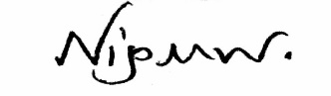

|  |  |
| --- | --- |
| Name: Sadman Salim Nipun  Id: 20-44345-3  Department of Computer Science | Name: Mohammad Shuvo Ali  Id: 20-43240-1  Department of Computer Science |
| Name: Umma Shara Ali Setu  Id: 20-43223-1  Department of Computer Science | Name: Mahashetab Hasan  Id: 20-44361-3  Department of Computer Science |

**Approval**

This thesis titled “Blockchain-based Solution for Supply Chain Management: Tracking and Preventing Illegal Goods in Shipping Containers**”** has been submitted to the following respected member of the board of Examiners of the faculty of Science and Information Technology Impartial fulfillment of the requirements for the degree of Bachelor of Science in Computer Science and Engineering on December 1, 2023 and has been accepted satisfactory.

|  |  |
| --- | --- |
| **DR. MD. ABDULLAH - AL – JUBAIR**  Assistant Professor &Supervisor  Department of Computer Science  American International University-Bangladesh | **TASLIMUR RAHMAN**  Lecturer & External  Department of Computer Science  American International University-Bangladesh |
| |  |  | | --- | --- | | **DR. AKINUL ISLAM JONY**  Associate Professor &Head (UG) Department of Computer Science  American International University-Bangladesh | **DR. DIP NONDI**  Professor and Associate Dean  Faculty of Science and Technology  American International University-Bangladesh |   **MASHIOUR RAHMAN**  Dean  Faculty of Science and Technology  American International University-Bangladesh | |

# **Acknowledgement**

This Thesis is our cordial effort and our supervisor’s initiative and constant motivation. But first, we would like to be grateful to the Almighty Allah, who gave us the effort to work on this thesis for the last one semester. Especially thanks go to our honorable supervisor faculty member, American International University-Bangladesh [AIUB] for his enormous support, inspiration, and helpful criticism. His excellent supervision and constant support make this thesis possible. We are very grateful to him for giving us the opportunity to work with him. We also convey our thanks to our honorable Vice Chancellor, Dr. Carmen Z. Lamagna, our Dean, Mashiour Rahman, our Director, Dr. Md. Abdullah - Al – Jubair, and our Head of Department Dr. Akinul Islam Jony for their constant motivation and support.

Finally, yet importantly, we thank our respectable parents for educating us with aspects from both arts and sciences, for their unconditional support and encouragement to pursue our interests, even when interests went out of boundary.

#### **Abstract**

Blockchain technology could be a game-changing solution to the problem of illicit items in the supply chain, especially for shipping container management. The introduction of illicit goods into shipping containers is one of the most urgent problems facing supply chain management. This study examines the potential of using blockchain technology to solve the problem and assist in overcoming these issues and significantly improving the logistics business. The proposed blockchain system seeks to improve trust, security, and traceability, addressing this problem and promoting global trade. Within this decentralized environment, user data and transactions find secure storage on the blockchain, fostering transparency and immutability. Interactions within decentralized applications (dApps) occur smoothly, frequently involving cryptocurrency transactions executed without the need for intermediaries. In the developmental process of dApps, crucial considerations revolve around security, scalability, and user experience. These factors serve as guiding principles, ensuring the dependability and user-friendly nature of the emerging decentralized applications for shipping container management.

**Keywords**: Blockchain technology, Decentralized application, Security, Shipping container management, Illicit items, Supply Chain, dApps, Scalability, Transparency, Immutability, Dependability, Secure storage.

**Table of Contents**

**Topics**

DECLARATION…... ii

APPROVAL iii

ACKNOWLEDGEMENT

ABSTRACT

LIST OF FIGURES & TABLES TABLE OF CONTENTS

CHAPTER ONE: INTRODUCTION 1

* 1. Overview…………………………………………………………………………1
  2. Background Study………………………………………………………………..1
  3. Problem Statement……………………………………………………………….3
  4. Objective of the Study……………………………………………………………4
  5. Contribution……………………………………………………………………...4
  6. Summary…………………………………………………………………………5

**CHAPTER TWO: LITERATURE REVIEW………………………………………………6**

2.1 Overview…………………………………………………………………………6

2.2 Supply Chain Security…………………………………………………………...6

2.3 Traditional Methods of Tracking of Shipping Containers……………………….7

2.4 Blockchain……………………………………………………………………….9

2.4.1 Ethereum Blockchain………………………………………………….11

2.4.2 Smart Contract………………………………………………………...12

2.5 Blockchain-Based Logistic Monitoring System………………………………...14

2.5.1 Unlocking Value in Logistics………………………………………….14

2.5.2 Blockchain in Logistics………………………………………….........15

2.5.3 Faster and Leaner Logistics in Global Trade………………………….16

2.5.4 Improving Transparency and Traceability in Supply Chain……..........17

2.5.5 Automating Logistics Commercial Process with Smart Contracts……17

2.6 Blockchain Security…………………………………………………………….17

2.6.1 Blockchain Types and Security Threats………………………………18

2.7 Tracking and Detecting Blockchain……………………………………………19

2.8 Decentralized Applications…………………………………………………….20

2.8.1 Popular Decentralized Applications (dApps), Advantages and

Disadvantages………………………………………………………...20

2.9 Related Work…………………………………………………………………..21

2.10 Summary……………………………………………………………………..22

**CHAPTER THREE: METHODOLOGY………………………………………………...23**

3.1 Overview………………………………………………………………………23

3.2 Overview of the Blockchain Technology……………………………………...23

3.2.1 Ethereum Blockchain…………………………………………...........23

3.2.2 Solidity……………………………………………………………….24

3.2.3 Smart Contracts………………………………………………………24

3.2.4 Decentralized Applications (dApps)…………………………………24

3.3 Development Methodology…………………………………………………...25

3.3.1 Suitable for small Teams…………………………………………….25

3.3.2 Accelerated Application Development………………………………26

3.3.3 Testing Integration…………………………………………………...26

3.3.4 Adaptability to Changes……………………………………………..26

3.3.5 Emphasis on Continuous Improvement……………………………..26

3.4 Research Design………………………………………………………………26

3.4.1 Agile Framework Implementation…………………………………..26

3.5 Development Process…………………………………………………………27

3.5.1 Agile Iteration……………………………………………………….27

3.5.2 Collaboration………………………………………………………..28

3.5.3 Continuous Integration……………………………………………...28

3.6 Tools and Technologies………………………………………………………29

3.6.1 Solidity- The Smart Contract Programming Language…………….29

3.6.2 Remix IDE – Integrated Development Environment………………29

3.6.3 MetaMask- Ethereum Wallet and Gateway to Blockchain………...29

3.6.4 DappOS Framework- Simplifying dApp Development…………...29

3.6.5 Etherscan -Blockchain Explorer and Analytics Platform………….29

3.6.6 Test Network- Ensuring Secure Development…………………….29

3.6.7 Web3.js- JavaScript Library for Ethereum Interactions…………...30

3.6.8 Ethers- Ethereum JavaScript Library……………………………...30

3.7 Limitations (Methodological Limitations)………………………………….30

3.8 Summary ……………………………………………………………………31

**CHAPTER FOUR: IMPLEMENTATION…………………………………………...31**

4.1 Overview……………………………………………………………………31

4.2 Technical Details and Architecture…………………………………………31

4.3 Blockchain Network Setup…………………………………………………33

4.4 Smart Contract Development and Deployment…………………………….36

4.5 Decentralized Application (dApp) Development…………………………..40

4.6 Data Storage and Encryption……………………………………………….42

4.7 Result and Findings………………………………………………………...43

4.8 Summary……………………………………………………………………44

**CHAPTER FIVE: CONCLUSION……………………………………………………45**

5.1 Overview……………………………………………………………………45

5.2 Summary of the Proposed Blockchain-Based Solution…………………….45

5.3 Contribution to Supply Chain Management………………………………..46

5.4 Key Findings………………………………………………………………..46

5.5 Significance of the Study…………………………………………………...47

5.6 Limitations………………………………………………………………….48

5.7 Future Work………………………………………………………………...49

5.8 Integration with Industry Practices…………………………………………50

5.9 Conclusion………………………………………………………………….51

5.10 Summary…………………………………………………………………..51

**REFERENCES…………………………………………………………………………52**

#### **List of Figure**

Fig 1.1: Supply Chain Management of Shipping Containers……………………………..2

Fig 2.1: Bill of Lading…………………………………………………………………….8

Fig 2.2: Shipping container numbering system…………………………………………...8

Fig 2.3: Blockchain Technology………………………………………………………….10

Fig 2.4: Peer to peer network……………………………………………………………..11

Fig 2.5: Smart Contract…………………………………………………………………...13

Fig 2.6: In international trade, information exchange is difficult………………………...15

Fig 2.7: Key blockchain use cases in logistics……………………………………………16

Fig 2.8: Blockchain can simplify international freight transportation……………………17

Fig 2.9: Distinctions between permissioned private blockchains and public,

permissionless blockchains……………………………………………………...18

Fig 3.1: Structure of an Ethereum blockchain node……………………………………...23

Fig 3.2: Traditional Contracts vs Smart Contracts……………………………………….24

Fig 3.3: Apps vs dApps…………………………………………………………………..25

Fig 3.4: Agile Methodology……………………………………………………………...25

Fig 4.1: Structure of a Block in Blockchain……………………………………………...32

Fig 4.2: Ethereum Architecture…………………………………………………………..33

Fig 4.3: Ethereum Decentralized Application Architecture……………………………...34

Fig 4.4: Remix IDE for Ethereum Blockchain development…………………………….34

Fig 4.5: MetaMask Wallet………………………………………………………………..35

Fig 4.6: MetaMask Ethereum Transaction……………………………………………….35

Fig 4.7: Smart Contract Development……………………………………………………36

Fig 4.8: Solidity code for Shipping Container Management……………………………..37

Fig 4.9: Solidity code for Shipping Container Management……………………………..37

Fig 4.10: Smart Contract Compilation and Deployment…………………………………38

Fig 4.11: Smart Contract Functionality…………………………………………………..38

Fig 4.12: Data insertion and Transaction created………………………………………...39

Fig 4.13: Fetching the data and details of transaction fee………………………………..39

Fig 4.14: Deploying the dApp in test network and using faucet for mining Ethereum….40

Fig 4.15: Verification of Smart Contract Deployment in Blockchain……………………41

Fig 4.16: Decentralized Application Interface……………………………………………41

Fig 4.17: Decentralized Application Interface……………………………………………42

### Fig 4.18: Data Security of Blockchain……………………………………………………43

**List of Table**

Table 3.5.1: Agile Iterations…………………………………………………………....

# **Chapter One**

**Introduction**

# **Overview**

A multidimensional network that makes it easier to transport products, services, and information across international borders is the global supply chain ecosystem. It serves as the foundation of contemporary business, facilitating the exchange of goods between different parties, including producers, suppliers, distributors, and customers. But a variety of difficulties confront this complex system. Among these difficulties, the introduction of illicit items into shipping containers is one of the most important problems presently facing supply chain management. In addition to endangering security, the inclusion of illegal goods in authorized cargo shipments undermines confidence in international trade and puts public safety at serious risk.

The main goal of this thesis is to examine the potential of blockchain technology as a game-changing solution to the urgent problem of illicit items in the supply chain. This study attempts to give a thorough knowledge of how blockchain may be used to prevent the transportation of illicit products cloaked inside apparently legitimate cargo shipments by exploring its use within the field of supply chain management.

In the succeeding chapters, we will examine the complexities of supply chain management in greater depth., highlight the ongoing difficulties it encounters, and present novel approaches for utilizing blockchain technology to improve transparency, traceability, and security within this crucial economic framework. This study will examine the theoretical underpinnings, investigative techniques, and real-world applications of blockchain-based supply chain solutions.

This thesis sets out on a quest to strengthen the fundamental pillars of international trade and commerce by using the transformational potential of blockchain technology. It focuses on the problem of illicit items being smuggled into shipping containers. This study intends to contribute to the growing body of knowledge. in supply chain management and blockchain technology via thorough research and analysis, ultimately providing practical insights into a more secure and accountable future for supply networks throughout the world.

## **Background Study**

The global economy depends heavily on the dynamic and complex discipline of supply chain management. From the purchase of raw materials through the creation of products, their distribution, and eventually their consumption, it involves a vast range of operations. In the

modern environment, supply chains have developed into intricate networks that traverse international borders and link enterprises, suppliers, and customers.

Supply networks have historically been essential to human civilization, supporting commerce along historic routes like the Silk Road and fostering the expansion of world empires. The difficulties and complexity faced by supply chain management, however, have increased dramatically in the modern period.

The infiltration of illicit items into shipping containers inside the supply chain is one of the most urgent concerns. As trade routes have opened and the number of products being shipped throughout the world has risen, this problem has gained more and more attention. Multiple hazards might arise from the concealment of prohibited or illicit products in regular cargo shipments.

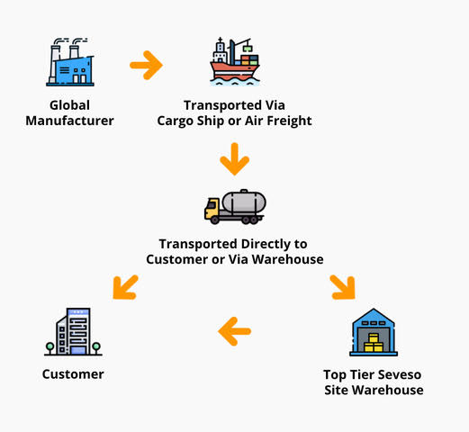

**Fig 1.1: Supply Chain Management of Shipping Containers**

These dangers go beyond purely economic considerations to include security, trade integrity, and public safety concerns. counterfeit goods, contraband, smuggled goods, and even dangerous materials can all be considered illegal goods. Such intrusions can have a variety of negative effects, including possible harm to customers and wider society as well as financial losses for corporations. Additionally, these actions damage the reputation of both countries and enterprises by undermining confidence in the dependability and security of international commerce.

Innovative solutions are essential to address these issues. The development of blockchain technology has provided a glimmer of hope for efficiently resolving these problems. Blockchain has drawn attention because it has the ability to completely transform supply chain management. Blockchain was first designed as a distributed ledger for cryptocurrencies like Bitcoin.

The main characteristics of blockchain, including decentralization, transparency, immutability, and security, make it a desirable choice for boosting supply chain operations' level of trustworthiness. Blockchain technology promises to give real-time insight into the flow of commodities, assuring accountability at every stage of the supply chain by storing transactions and data in a tamper-resistant and openly available ledger.

As we go more into this thesis, we will examine the complexities of supply chain management, the historical and modern difficulties it encounters, and the ways in which blockchain technology might be a ray of hope in tackling the smuggling of illegal commodities into shipping containers. In order to lay the groundwork for a thorough knowledge of the revolutionary potential of blockchain within the context of supply chain security, we will analyze existing research and solutions relevant to this problem.

## **Problem Statement**

A persistent and unsolvable problem, the smuggling of illicit products into shipping containers, looms large inside the immense length of the global supply chain. The global supply chain management industry continues to face an urgent and severe challenge as a result of this issue, which has persisted despite continued efforts. The capacity of current tracking and monitoring techniques to effectively stop and detect these illegal actions has been lacking.

Traditional supply chain monitoring methods sometimes fall short of having the qualities needed to effectively stop the trafficking of illicit items. They fail to preserve immutable records, which are essential for correctly recognizing, reporting, and discouraging the transit of illicit goods, as well as providing real-time insight into the complex web of supply chain operations.

One of the critical issues lies in the lack of transparency within the existing supply chain systems. The opacity of transactions and movements within the supply chain contributes to the smuggling problem. Current systems often conceal crucial information, making it difficult to track and verify the legitimacy of cargo.

In addition to transparency issues, the absence of a decentralized and tamper-resistant medium in traditional systems opens the door to manipulation and fraud. The lack of a secure and distributed ledger allows bad actors to alter records, facilitating the covert transportation of illegal goods.

Traditional supply chain systems lack the robustness and mobility required to adapt to the dynamic and global nature of modern commerce. This limitation hampers the ability to respond swiftly to emerging threats, such as the smuggling of illicit items, and to maintain the supply chain's integrity. The existing systems often fail to maintain this due to their vulnerability to tampering and fraud. Illicit products can infiltrate lawful cargo shipments without leaving a trace, compromising the overall trustworthiness of the supply chain.

Beyond its negative effects on the economy, this issue persists. The security and integrity of the global supply chain are seriously threatened by the inclusion of illicit products in purportedly lawful cargo shipments. It erodes consumer and company confidence, calls into question the dependability of global commerce, and might have negative effects on public safety.

Therefore, it is obvious that the problem of the smuggling of illegal items into shipping containers requires an innovative and transformational approach immediately. In order to address the issue, this study suggests a blockchain-based solution that aims to greatly improve the traceability and security of items along the supply chain. It specifically seeks to prevent the clandestine movement of illicit items, preserving the integrity of the supply chain and supporting the basis of international trade.

# **1.4 Objective of The Study**

In this research, we are proposing to design a blockchain-based solution for supply chain management that tracking and preventing illegal goods in shipping containers. These research goals should direct efforts to promote the detection and avoidance of illegal commodities in shipping containers, enhancing security, facilitating trade, and adhering to international laws. Thus, the system will be developed on the basis of output from the model.

Specific objectives are given below:

1. Design a blockchain-based system that can securely record and manage data related to shipping container contents, routes, and custody changes.
2. Develop smart contracts and consensus mechanisms that validate the accuracy of information added to the blockchain while preserving privacy and confidentiality.
3. Investigate methods for integrating data from various stakeholders, including customs authorities, shipping companies, and regulatory bodies.
4. Review and make suggestions for improvements to the processes used by customs and border control to inspect shipping containers.
5. Create methodologies for risk assessment and profiling to identify high-risk shipments and containers.
6. Analyze the financial effects of illegal products in shipping containers, considering the effect on trade, industry, and national security.

# **1.5 Contribution**

Tracking and preventing illegal goods in shipping containers offers several significant contributions to various aspects of society and the global economy. This system reduces the risk of illicit activities such as smuggling, terrorism, and organized crime through the global supply chain. Preventing illegal goods in shipping containers helps protect legitimate businesses and industries from unfair competition and economic losses caused by counterfeit products and illicit trade. In this study, trade facilitation contributes to smoother international trade, faster shipping times, and lower costs for businesses engaged in legitimate trade. This system also helps countries and companies comply with international regulations and trade agreements, ensuring that products meet quality, safety, and intellectual property standards. The protection of intellectual property rights provided by efforts to stop the sale of unlawful items benefits inventors, entrepreneurs, and businesses that rely on patents, trademarks, and copyrights for their goods. In this study, the integrity of customs and law enforcement agencies can be improved by reducing corruption. This research protects the integrity and safety of the supply chain must include the tracking and interdiction of illegal items in shipping containers due to their extensive positive effects on security, trade, economics, and society.

The preservation of endangered species and habitats, essential for biodiversity and sustainability, is facilitated by the prevention of illegal wildlife trade and environmental smuggling. International cooperation and information exchange between nations, customs officials, shipping industry players, and international organizations are necessary to address the issue of illegal products in shipping containers.

Beyond container security, tracking technology research and development foster innovation in industries like logistics, sensor technology, data analytics, and artificial intelligence. In this study, public education campaigns regarding the dangers of illegal goods and the value of prevention and tracking result in informed consumer decisions and ethical company activities. In order to establish ethical and legal frameworks that balance security, privacy, and trade interests, future policies and laws will be guided by the fight against illegal commodities.

In this research, the establishment of legal and moral frameworks that strike a balance between security, privacy, and commerce interests is facilitated by efforts to eliminate unlawful goods. These models can serve as a roadmap for future legislation and policy. By maintaining the integrity and safety of the global supply chain, tracing and blocking the shipment of illegal items has far-reaching positive effects, enhancing security, trade, economics, and society.

# **1.6 Summary**

In the first section, we have discussed the smuggling of illegal goods in shipping containers is one of the biggest problems facing the global supply chain ecosystem, which is essential for international trade. This thesis investigates how supply chain security and transparency can be improved via blockchain technology to address this problem. In the problem statement part, we build a blockchain-based solution has been proposed in response to the ongoing problem of smuggling illegal items into shipping containers across the global supply chain. Traditional monitoring techniques have failed to maintain supply chain integrity by failing to ensure transparency and stop manipulation. The suggested blockchain system seeks to improve trust, security, and traceability, addressing this problem and promoting global trade. In the objective section, we have discussed a safe blockchain system for storing shipping data, the creation of precise smart contracts, the incorporation of stakeholder information, the enhancement of customs procedures, the assessment of shipment risk, and the evaluation of the financial impact of illicit goods in shipping containers. In contribution part, we have explained lowers risks like terrorism and drug trafficking, safeguards intellectual property rights, ensures compliance with laws, makes international trade run more smoothly, protects legitimate businesses from unfair competition, fights corruption, and ultimately improves security, trade, economics, and society at large.

**Chapter Two**

**Literature Review**

**2.1 Overview**

Supply chain security is a critical problem for businesses of all sizes. In today's globalized economy, supply chains are complex and linked, making them subject to a range of dangers, including cyberattacks, theft, and fraud. This chapter will analyze the literature on supply chain security, with a focus on blockchain technology. Blockchain is a decentralized system of recording information that has the capacity to revolutionize the management of supply chains. By providing a secure and accessible record of all transactions, blockchain can assist in improving supply chain visibility and traceability and reduce the risk of fraud and counterfeiting.

**2.2 Supply Chain Security**

Supply chain security is the practice of securing the supply chain from a few dangers, including cyberattacks, theft, and fraud. [1] The supply chain covers all the acts involved in the manufacturing, transportation, and delivery of goods and services. It includes suppliers, manufacturers, distributors, and retailers, as well as the transportation and logistics companies that connect them. [1] Supply chain security is crucial for several reasons, including:

* **Financial losses:** Supply chain interruptions can lead to missed revenue, product recalls, and damage to reputation. [1] For example, the 2011 Toyota recall cost the corporation approximately $1.1 billion in revenue. [2]
* **Consumer safety:** Counterfeit and contaminated products can pose a major health risk to consumers. [1] For example, in 2018, the US Food and Drug Administration (FDA) alerted customers about a counterfeit version of the blood thinner Xarelto that was circulating online. The counterfeit medicine was found to contain a different active ingredient than the original drug and might have caused catastrophic side effects, including stroke and death. [3]
* **National security:** Strategic industries, such as food, energy, and medicines, are particularly sensitive to supply chain disruptions. [1] In 2015, the US government alleged that China engaged in cyber invasion by unlawfully accessing the computer networks of American corporations with the intention of misappropriating intellectual property related to solar panel technology. [4]

Common supply chain security threats include:

* **Cyberattacks:** Cyberattacks can be used to disrupt supply chain operations, steal secret data, or start ransomware attacks. [5] For example, in 2017, the NotPetya ransomware assault caused billions of dollars in damage to organizations throughout the world, including numerous companies in the supply chain sector. [6]
* **Theft:** Theft of goods and materials is a common danger to supply systems. [5] Theft can occur at any step in the supply chain, from raw materials to completed products. For example, in 2018, a shipment of $10 million worth of computer chips was stolen from a facility in China. [7]
* **Fraud:** Fraud can occur in many different forms in the supply chain, such as counterfeit products, invoice fraud, and cargo theft. [5] For example, in 2019, a gang of persons was arrested for counterfeiting and selling over $100 million worth of car parts. [8]

Organizations can take several initiatives to improve their supply chain security, including:

* **Conducting risk assessments:** Identifying and assessing the risks to the supply chain is the first step to building a complete security plan. [5] Risk assessments should be undertaken on a regular basis to verify that the security plan is up-to-date and effective.
* **Implementing security controls:** Once the risks have been determined, businesses can apply security measures to mitigate those risks. [5] Security controls can include physical security measures, such as fences and security guards, as well as IT security measures, such as firewalls and intrusion detection systems.
* **Monitoring and responding to incidents:** Organizations should have a plan in place for monitoring and responding to security incidents. [5] This strategy should include methods for detecting, investigating, and containing issues.

Supply chain security is a complex and ever-evolving challenge. However, by implementing the procedures indicated above, firms can strengthen their security posture and lower the risk of supply chain interruptions.

**2.3 Traditional Methods of Tracking of Shipping Containers**

Traditional methods of tracking shipping containers rely on paper-based documentation and manual data entry. This can make it difficult to trace the movement of items in real time and to spot possible difficulties.

One typical traditional approach of tracing shipping containers is to utilize a bill of lading. An official document given by the carrier to the shipper is called a bill of lading. It provides information on the cargo, such as the origin, destination, type of merchandise, and number of items. The bill of lading is used to trace the shipment throughout the supply chain [9].

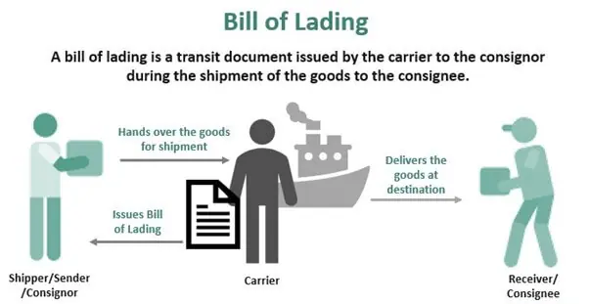

**Fig 2.5: Bill of Lading**

Another frequent traditional technique of tracking shipping containers is to utilize container numbers. Each shipping container has a unique identifying number. This number is used to track the container as it moves through the supply chain.

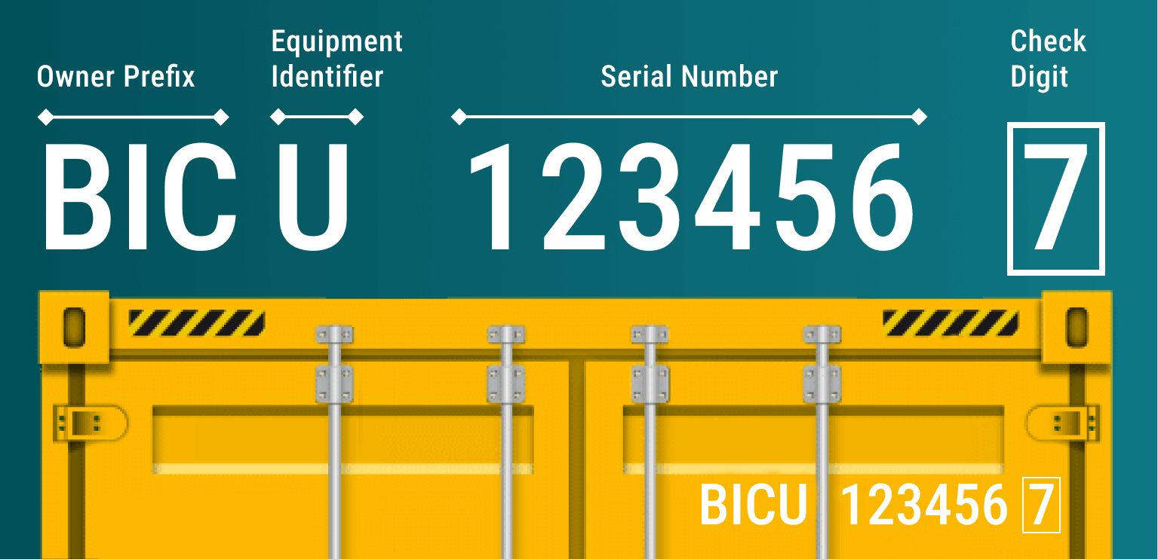

**Fig 6.2: Shipping container numbering system**

Traditional techniques of tracking shipping containers can be time-consuming and inefficient. They are also prone to errors. For example, if a bill of lading is missing or damaged, it can be difficult to track the shipment. Additionally, if data is submitted incorrectly, it can lead to false tracking information.

Emerging technologies for tracking shipping containers:

There are a variety of developing technologies that can be utilized to improve the tracking of shipping containers. These technologies include:

* GPS: GPS may be used to track the location of shipping containers in real time. This can assist firms to identify the location of their shipments at any given time and to follow the movement of items through the supply chain.
* RFID: RFID tags can be attached to shipping containers to track their movement. RFID tags are scanned by RFID readers, which are situated at important points in the supply chain, such as ports and warehouses. This can offer real-time data on the position of shipping containers.
* IoT: The Internet of Things (IoT) can be used to track shipping containers and collect data about their condition. For example, IoT sensors can be used to track the temperature and humidity within shipping containers. This data can be used to verify that commodities are transported in the correct circumstances.

Emerging technology can allow firms to improve the tracking of shipping containers and to increase supply chain visibility and traceability.

**2.4 Blockchain**

Blockchain is a decentralized system that enables secure, transparent, and immutable record-keeping using distributed ledger technology (DLT) [10]. Essentially, it is a distributed database where multiple computers on a network each possess a copy of the database. This makes blockchain highly resistant to fraud and hacking, as it is extremely difficult to change or destroy data on the blockchain without being caught.

Blockchain works by storing data in blocks, which are then chained together to build a tamper-proof record. Each block includes a timestamp, a link to the previous block, and a transaction list. When a new transaction is added to the blockchain, it is validated by all of the computers in the network. Once the transaction is verified, it is appended to a new block and the block is added to the chain.

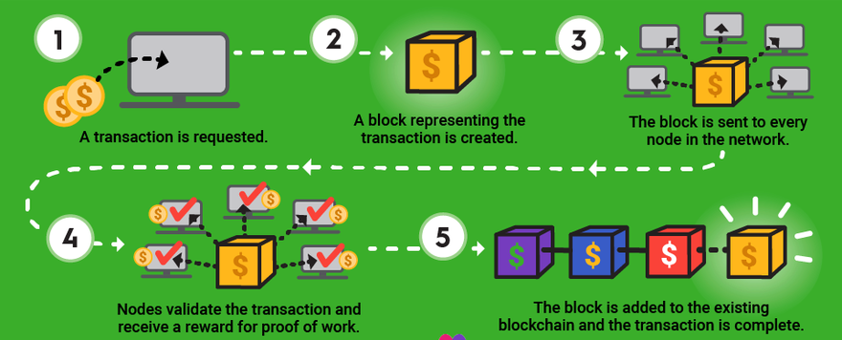

**Fig 2.7: Blockchain Technology**

Blockchain has the potential to change numerous industries, including supply chain management. By providing a secure and transparent record of all transactions, blockchain can assist firms to:

* **Improve visibility and traceability:** Blockchain can be used to track how goods move through the supply chain, from raw materials to finished goods. This might enable firms to notice probable problems earlier on and to take corrective measures. For example, blockchain can be used to identify shipments that are delayed or damaged, or to identify counterfeit goods [11].
* **Reduce fraud and counterfeiting:** Blockchain may be used to authenticate the authenticity of items and to track their ownership along the supply chain. This can help to prevent fraud and counterfeiting, which is a big problem in many businesses [12].
* **Increase efficiency:** Blockchain can automate many of the human operations involved in supply chain management, such as tracking inventories and processing payments. This can allow firms to enhance efficiency and cut expenses.
* **Enhance collaboration:** Blockchain can assist firms to cooperate more effectively with their suppliers and customers. For example, blockchain can be used to build a shared ledger of data that can be accessible by all parties engaged in a supply chain.

Here are some concrete instances of how blockchain is being used in supply chain management:

* Walmart is utilizing blockchain to trace the movement of food via its supply chain. This helps Walmart to verify that food is safe and to spot possible concerns early on.
* Maersk is automating the shipping process with blockchain technology. This helps to decrease paperwork and delays, and to make the shipping process more efficient.
* IBM is collaborating with several firms to create blockchain-based solutions for supply chain management. These solutions are being utilized to improve visibility and traceability, minimize fraud and counterfeiting, and increase efficiency.

## **2.4.1 Ethereum Blockchain**

Ethereum is a decentralized blockchain platform that supports the development of smart contracts and applications that are decentralized (dApps). According to the market value, it is the second-biggest cryptocurrency after Bitcoin. With Ethereum, there is no central authority controlling it because it is a peer-to-peer network. A group of nodes (computers) keep the network running. Each node runs a copy of the Ethereum blockchain and helps validate and process transactions [13].

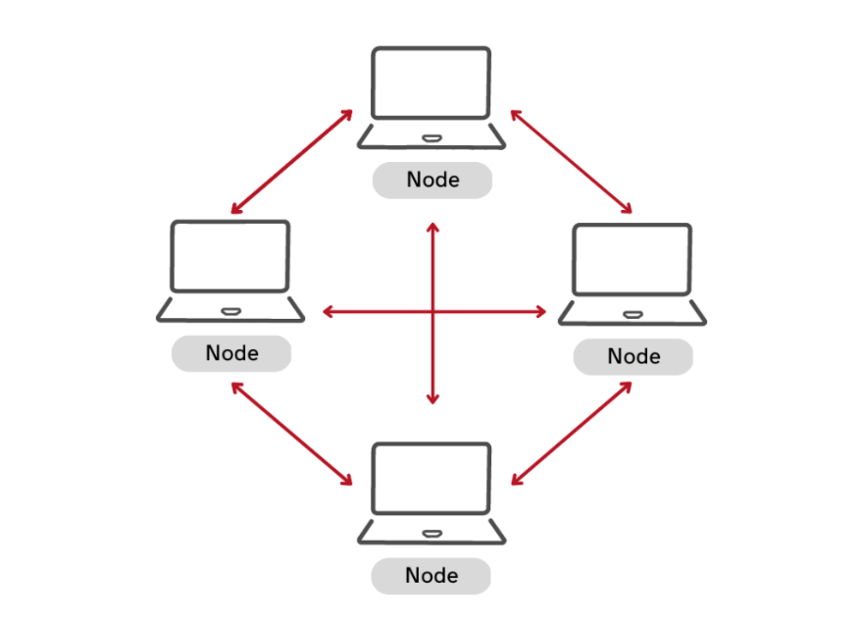

**Fig 2.8: Peer to peer network**

Transactions on the Ethereum network are divided into blocks. Each block is validated by miners and then uploaded to the blockchain. Miners are rewarded with Ether (ETH) for their labor [13].

There are two basic types of Ethereum blockchain networks: public and private.

* **Public Ethereum blockchain:** Public Ethereum blockchain networks are open to anybody to join. This is the type of Ethereum blockchain network that is used for most dApps and bitcoin transactions [14].
* **Private Ethereum blockchain:** Private Ethereum blockchain networks are only accessible to authorized users. This form of Ethereum blockchain network is often utilized by enterprises for supply chain management, financial services, and other applications [14].

Ethereum blockchain can be used for supply chain and shipping container tracking in a few ways. For example:

* **Tracking the flow of goods:** The Ethereum blockchain has the capability to monitor the movement of commodities throughout the supply chain, starting from the initial raw materials and ending with the final products. This can allow firms to identify possible problems early on and to take corrective measures [15].
* **Managing inventory:** Ethereum blockchain can be used to manage inventory levels more efficiently. For example, Ethereum blockchain can be used to trace the movement of items between warehouses and to automate the reordering process [15].
* **Processing payments:** Ethereum blockchain can be used to handle payments between suppliers and customers more rapidly and securely. For example, Ethereum blockchain can be used to automate the release of payments once goods have been received and inspected [15].
* **Managing compliance:** Ethereum blockchain can be used to manage compliance with regulations such as food safety and environmental standards. For example, Ethereum blockchain can be used to track the origin of food goods and to confirm that they have been manufactured and delivered in a safe and sustainable manner [15].

There are a lot of benefits to adopting Ethereum blockchain for supply chain and shipping container tracking, including:

* **Transparency:** Ethereum blockchain is a transparent technology, which means that all transactions can be viewed by everyone on the network. This can help to develop trust between businesses and consumers [16].
* **Security:** Ethereum blockchain is a secure technology. Transactions on the Ethereum blockchain are encrypted and cannot be tampered with. This can help to safeguard firms from fraud and counterfeiting [16].
* **Efficiency:** Ethereum blockchain can allow firms to streamline their supply chains and boost efficiency. For example, Ethereum blockchain can be used to automate many of the human operations required in supply chain management [16].
* **Collaboration:** Ethereum blockchain can assist firms to collaborate more efficiently with their suppliers and customers. For example, Ethereum blockchain can be used to build a shared ledger of data that can be accessible by all parties engaged in a supply chain [16].

There are a variety of hurdles to using Ethereum blockchain for supply chain and shipping container tracking, including:

* **Scalability:** Ethereum blockchain is not yet extremely scalable, Consequently, it has a limited capacity to handle a specific quantity of transactions within a given time frame. This can be an issue for businesses that need to track a high number of shipments [17].
* **Cost:** The cost of adopting Ethereum blockchain might be considerable, especially for organizations that need to track a big number of shipments [17].
* **Complexity:** Ethereum blockchain is a sophisticated technology, which might make it challenging for enterprises to install and use [17].

## **2.4.2 Smart Contract**

A smart contract is an autonomous contract where the terms of the agreement between the buyer and seller are encoded directly into lines of code, allowing for automatic execution. The code and agreements are distributed across a decentralized blockchain network. Smart contracts enable secure transactions and agreements to be conducted between different, unidentified individuals without the need for a trusted intermediary.[18] Smart contracts are recorded on a blockchain, which is a distributed ledger that is shared by all participants in the network. This signifies that all transactions are transparent and cannot be altered.

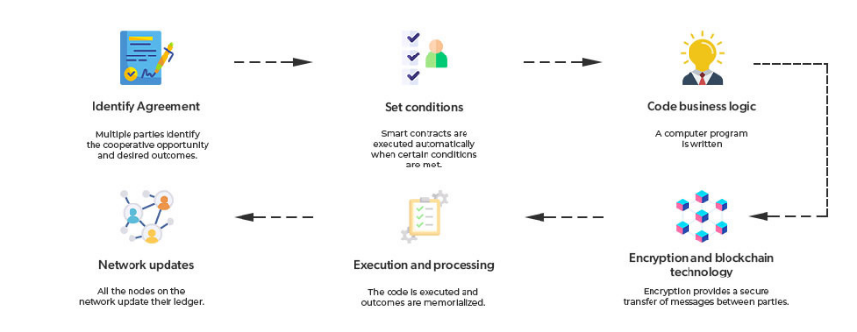

**Fig 2.9: Smart Contract**

Solidity is a computer language used to develop smart contracts. High-level programming languages like JavaScript are comparable to Solidity. Once a smart contract is constructed, it is published to the blockchain. Once a smart contract is launched, it cannot be altered. When a transaction is initiated on a smart contract, the code is performed, and the terms of the contract are carried out [18].

There are many distinct forms of smart contracts. Here are a few examples:

* **Financial contracts:** Financial tasks like payments and insurance claims can be automated with the help of smart contracts.
* **Supply chain management:** Smart contracts can be used to automate payments between suppliers and clients as well as track the movement of commodities.
* **Voting:** Safe and transparent voting procedures can be established with the use of smart contracts.
* **Gaming:** Decentralized gaming and gambling systems can be established with smart contracts.

Smart contracts can be used for supply chain and shipping container tracking in a few ways. For example:

* **Tracking the flow of goods:** Smart contracts can be used to trace the movement of commodities across the supply chain from raw materials to completed products. This can allow organizations to spot possible problems early on and to take corrective action.
* **Managing inventory:** Smart contracts enable the more efficient management of inventory levels. Smart contracts can facilitate the monitoring of item transfers between warehouses and streamline the process of reordering.
* **Processing payments:** Smart contracts can be used to process payments between suppliers and customers more rapidly and securely. For example, smart contracts can be used to automate the distribution of money once goods have been received and inspected.
* **Managing compliance:** Smart contracts can be utilized to oversee adherence to regulations, such as those pertaining to food safety and environmental standards. Smart contracts can be employed to trace the source of food products and verify their production and delivery in a secure and environmentally friendly manner.

There are a variety of benefits to adopting smart contracts for supply chain and shipping container tracking, including:

* **Transparency:** Since smart contracts are visible, everybody on the network may observe every transaction. This may contribute to the growth of consumer and business trust.
* **Security:** Smart contracts are secure and cannot be tampered with. This can help to safeguard enterprises from fraud and counterfeiting.
* **Efficiency:** Organizations can increase efficiency and optimize their supply networks by implementing smart contracts. Smart contracts have the potential to automate numerous human functions involved in supply chain management, for instance.
* **Collaboration:** Smart contracts can help businesses communicate with their suppliers and customers more effectively. Smart contracts, for instance, can be used to create a shared data ledger that is available to all participants in a supply chain.

There are a variety of hurdles to adopting smart contracts for supply chain and shipping container tracking, including:

* **Scalability:** There is currently a limit to how many transactions smart contracts can process in a second due to their limited scalability. Organizations who have many shipments to track may find this to be problematic.
* **Cost:** The cost of adopting smart contracts might be considerable, especially for organizations that need to track a big number of shipments.
* **Complexity:** Smart contracts can be difficult to create and deploy. This can make them challenging for enterprises to deploy and use.

# **2.5 Blockchain-Based Logistic Monitoring System**

## **2.5.1 Unlocking Value in Logistics**

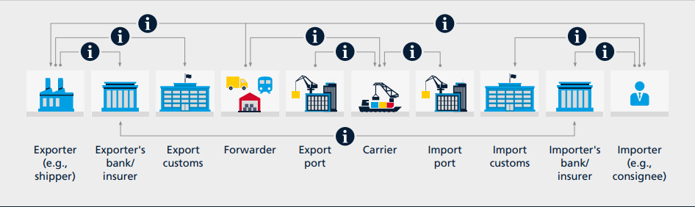

**Fig 2.6: In international trade, information exchange is difficult**

Collaboration is necessary to achieve logistics excellence by optimizing the transportation of physical goods, managing complex information flow, and facilitating financial transactions. Manual procedures mandated by regulatory agencies also limit a significant portion of the logistics value chain. For businesses to comply with customs regulations, transcription of data and paper-based records are typically used. These factors complicate the process of monitoring the locations of items and the progress of shipments throughout the supply chain, thereby hindering international trade. Blockchain technology has the potential to assist in overcoming these issues and significantly improving the logistics business.

This technology can facilitate data access and transparency for pertinent supply chain participants, establishing a single source of truth. Blockchain may power more automated, error-free, and leaner operations, which can result in cost savings. It can expedite the actual movement of products in addition to giving logistical operations more visibility and predictability. Provenance monitoring of items can assist combat product counterfeiting and enable large-scale, sustainable supply chains.

This system looks at some of the most well-known uses of blockchain technology in the areas of global trade logistics, commercial logistics processes, and supply chain transparency and traceability.

## **2.5.2 Blockchain in Logistics**

* **Blockchain Technology**: To create a decentralized and impenetrable ledger, employ blockchain technology. The blockchain records each and every movement, transaction, and modification to the shipping container's status. This guarantees the data's immutability and transparency.
* **Immutable Container History**: The origin, intermediate stops, and destination of the container are all preserved in an immutable history by the blockchain ledger. Authorized parties possess access to this information, guaranteeing transparency and confidence.

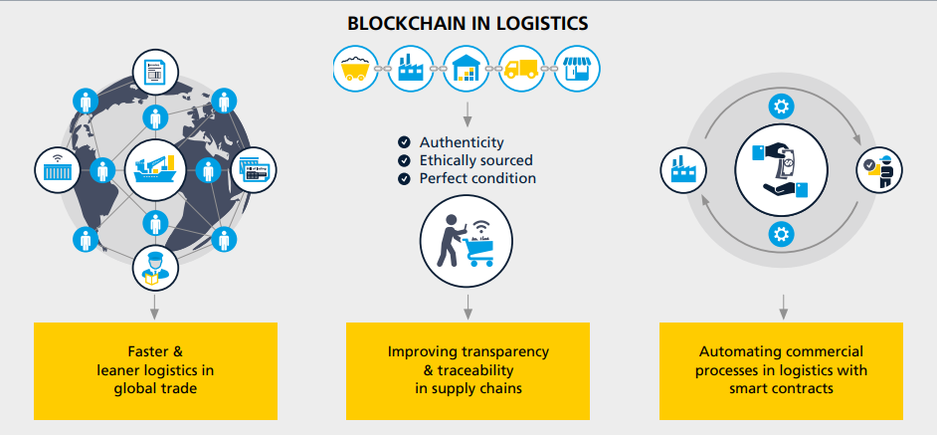

**Fig 2.7: Key blockchain use cases in logistics**

## **2.5.3 Faster and Leaner Logistics in Global Trade**

The worldwide shipping sector handles an estimated 90% of global trade annually, logistics is frequently seen as the backbone of the modern world. However, the logistics of international trade are extremely complicated since they include numerous parties, many of whom have competing interests and objectives, and they require the use of several tracking systems. Thus, the global economy is probably going to be significantly impacted by new trade logistics efficiency. Reducing trade obstacles in the supply chain could boost global trade by 15% and the GDP by about 5% according to a World Economic Forum assessment. Blockchain technology can be used to reduce several of the difficulties associated with international trade logistics, including trade financing, track and trace, customs cooperation, transportation management, and procurement.

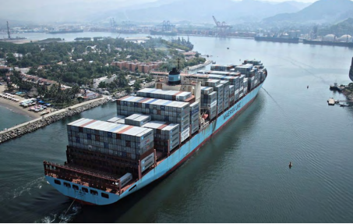

**Fig 2.8: Blockchain can simplify international freight transportation**

## **2.5.4 Improving Transparency and Traceability in Supply Chain**

Blockchain technology is being used in several projects to improve supply chain transparency and monitor provenance. These projects collect data, which is stored in a blockchain-based system, concerning the origins, manufacturing procedures, and management techniques of commodities. This makes the data permanent and easily shareable, giving supply chain players access to never-before-seen levels of track-and-trace power. Companies can use this information to provide certifications of authenticity and validity for luxury goods and pharmaceutical supplies, respectively.

## **2.5.5 Automating Logistics Commercial Process with Smart Contracts**

Industry estimates state that incorrect data appears in 10% of freight invoices, leading to disputes and various other inefficiencies in the logistics sector's operations. Accenture predicts that because the issue is so common, it may be possible to reduce overpayments and improve invoice accuracy, which may save at least 5% of annual freight expenses in the oil and energy sector alone. Blockchain can help settle conflicts in the logistics industry and greatly increase the efficiency of trade finance, logistics, and settlement procedures. Smart contract usage can be aided by the incorporation of digital documents and real-time shipment data into blockchain-based platforms. These contracts have the capacity to automate business processes under specified conditions.

# **2.6 Blockchain Security**

In a blockchain system, blockchain security is a thorough risk management process that is accomplished using cybersecurity frameworks, security testing procedures, and secure coding techniques. Blockchain solutions are shielded from online fraud, security breaches, and other cyberattacks by blockchain security. Maintaining the integrity and efficacy of the solution depends on securing a blockchain system for tracking and stopping illicit products in shipping containers.

**Mechanisms of Consensus**: To protect this network, used a suitable consensus method. By ensuring that all nodes concur on a transaction's authenticity, the consensus mechanism stops bad actors from changing the data.

**Encryption**: To protect data while it's in transit and at rest, use robust encryption techniques. Sensitive data, such transaction details and container contents, are kept private and unchangeable thanks to encryption.

**Smart Contract Security**: Carefully audit and safeguard smart contracts. Smart contract vulnerabilities may give rise to exploits. Use best practices for security and do routine code audits to find and address potential vulnerabilities.

**Permissioned Blockchain**: Consider utilizing a permissioned blockchain, in which usage is limited to individuals who have been given permission. This improves privacy and control, especially in a corporate setting where only specific organizations require access to the tracking information.

Conventional ledgers often offer an all-encompassing security layer that, if compromised, grants access to all information kept. The security features of a blockchain-based system ensure that each transaction and message is cryptographically signed. This ensures the basic protection and the risk management required to handle increasing risks of hacking, data manipulation, and data compromise.

## **2.6.1 Blockchain Types and Security Threats**

**Fig 2.9: Distinctions between permissioned private blockchains and public, permissionless blockchains**

Blockchains which are public, like Bitcoin, are accessible to everybody. Viewing the transaction history and starting new transactions is open to all users. Public blockchains can be costly and slow, but they are safe and decentralized. Most private blockchains are permissioned, which means that network access is governed by a central authority. In comparison, everyone can join public blockchains like Bitcoin. Users can personalize a hybrid blockchain by deciding which transactions are public or who is allowed to participate in it. The advantages of both public and private blockchains are combined in a hybrid blockchain. In consortium blockchains, a central authority within a blockchain network has preapproved known parties to take part in the consensus. Only pre-selected nodes are permitted to take part in the consensus process on a consortium blockchain.

# **2.7 Tracking and Detecting by Blockchain**

Tracking and detecting illegal goods in shipping containers using blockchain technology is a promising solution to enhance supply chain security and transparency. To gather data in real time, shipping containers can be equipped with sensors and RFID tags, among other IoT devices. These gadgets can keep an eye on variables like location, humidity, temperature, and container integrity. The blockchain network can receive data from Internet of Things devices. This data contains details on the location, status, and any anomalies found of the container. The blockchain records these data streams, giving rise to an unchangeable history of the container's travels. Data cannot be changed or removed after it has been recorded thanks to blockchain's immutability. This lowers the possibility of fraudulent activity by making the records tamper-proof.

**AI and Machine Learning**: Data gathered from Internet of Things devices can be analyzed using algorithms for artificial intelligence and machine learning. These algorithms are able to identify anomalies or patterns linked to the trafficking of illicit products, such as temperature variations that could signal the deterioration of perishable goods or unplanned detours.

**Verification &Authentication**: At many points in the supply chain, blockchain technology can be used to confirm the legitimacy of the commodities. This is especially crucial for sensitive or valuable material.

**Supply Chain actors:** The block-chain system can be accessed by the range of supply chain actors, including manufacturers, shipping firms, customs agencies, and customers. Transparency and real-time tracking of the contents of the container are made possible by this.

**Privacy, Alerts and Notifications:** The blockchain system has the ability to send out alerts and notifications to the appropriate parties, such law enforcement, or customs officials, for additional action when abnormalities are found. Blockchain technology can assist in guaranteeing adherence to national and international laws governing the transportation of commodities, including safety requirements, import and export restrictions, and trade sanctions. Even if blockchain technology is intrinsically safe, it's crucial to make sure that private data is properly safeguarded and that only people with permission can access information.

Collaboration between multiple stakeholders, investments in IoT infrastructure, and the creation of blockchain-based apps are necessary for the implementation of such a system. Furthermore, in the context of a global supply chain, it is imperative to solve privacy concerns, regulatory problems, and interoperability issues. Supply chain security and accountability can be increased by building a reliable system for tracking and identifying illicit commodities in shipping containers using blockchain technology in conjunction with IoT and AI.

# **2.8 Decentralized Applications**

Decentralized apps are meant to live on the Internet free from the control of a single entity. They operate on a peer-to-peer network of computers rather than a single computer. Several well-known instances of dApps that don't run on a blockchain framework are Tor, Kazaa,19, and BitTorrent.21 Blockchain addressed some of the constraints of programs, such as missing nodes and software damaged by viruses, while also giving users the ability to trust decentralized applications. Deploying a smart contract is necessary for the effective operation of decentralized applications on the blockchain. On these apps, several users can produce and consume content without any oversight or intervention from a single individual. Some of the dApps' requirements are listed below:

* **Open Source**: The codebase of dApps ought to be publicly accessible to anyone and should be open source. Only with the majority's consent should any modifications be made to the app's functionality or structure.
* **Decentralized:** To guarantee security and transparency, decentralized applications (dApps) should keep all of data and actions on a public, decentralized blockchain.
* **Incentive:** dApps ought to provide users with some kind of reward, such as cryptographic tokens. These are essentially liquid assets that give customers motivation to support the Blockchain dApp.
* **Protocol:** To provide evidence of their value, dApps must adhere to a specific protocol. This entails demonstrating a process's worth in a manner that makes it simple for others to confirm it.

## **2.8.1 Popular Decentralized Applications (dApps), Advantages and Disadvantages**

**Crypto-Kitties**: Crypto Kitties is an entertaining program that is enjoyable to use. Using cryptocurrency, we might purchase cats through the app, breed them, and then sell for a profit. Cute cats seem to be popular everywhere, even on Blockchain, as evidenced by the fact that 10% of Ethereum transactions were once handled by Crypto-Kitties every day.

**Open-Sea**: Open Sea is a decentralized application that promotes communication between different blockchain-based games. On Open-Sea, players can trade the collectibles because they have from any cryptocurrency game. Our dApp only supports Ethereum collection, but we have plans to expand.

**WINK**: The most widely used dApp on the market for games with a gambling theme is WINk. It featured everything from sports betting to dice games to poker. The TRON platform powers WINk, wherein wagering winners receive WIN tokens that may be exchanged for BTT, a cryptocurrency akin to Bitcoin.

**Advantages:** The network will still function when decentralized applications run on node, but the performance will be much worse**.** To utilize any app-specific features, users are not required to provide their real name or any other personal information. Because consensus techniques are used, data saved on the blockchain is unchangeable and impenetrable to tampering. Transactions on the blockchain cannot be forged, and data stored there is immutable. The Ethereum platform offers a versatile setting that makes developing dApps simple. Smart contracts don't require central authority supervision or intervention; they can be examined and are certain to operate in predictable ways.

**Disadvantages:** Ethereum requires high performance at the expense of security, transparency, and integrity. It takes a lot of time and computing power. Dapps are challenging to maintain, update and debug because published code and data on the blockchain are harder to alter because bug fixes require consensus from peers on the network, which are frequently impossible to accomplish rapidly. It is harder to scale decentralized networks than centralized ones. It is challenging for developers to construct a user-friendly dApp since users must log in using the public keys and private keys instead of the username and the password that are used for centralized applications.

# **2.9 Related Work**

It was proposed in 2019 and the benefits that supply blockchain technology provide to constructing a supply-chain, as well as the potential impediments that now impede blockchain integration into the global supply chain. [19] Barriers in blockchain can be categorized as external, technological, intra-organizational, or inter-organizational. We also look closely at how smart contracts are used to execute payments, transfer ownership, and promote transparency in information flow. Blockchain application in maritime supply chain The report emphasizes how inadequate The current shipping process administration is and demonstrates how blockchain technology may be used to rebuild the restrictive and ineffective system into one that fosters stakeholder confidence. They also talked about how blockchain can be used for tracking and tracing containers and digitizing documentation.[20]

Numerous blockchain applications in the maritime sector were examined. [21] They investigate the viability of integrating block-chain technology into the supply chain process in their paper. It comes to the conclusion that the papers they analyzed can be divided into three groups: financial processes, device connection, and documentation processes. Most of these applications emphasize and deal with comparable issues.

It carried out an extensive analysis of prominent cases, such as Trade-Lens and Blockchain Documentation Transaction System (BDTS), that seek to use blockchain technology to digitize shipping procedures. [22] Maersk and IBM collaborated on the blockchain technology Trade-lens, which uses an automated and secure documentation procedure. [23]

In an effort to reduce the negative effects of contaminated food—which include consumer harm, disruptions to business operations, and higher losses—Walmart and IBM collaborated to develop a blockchain-based system that tracks and traces products from point of origin to point of sale to end users. [24] For effective data recording, the system makes use of Hyperledger fabric with IBM's plug and play capabilities. Additionally, Evergreen tracks the origin of diamonds and their journey from mines to retailers by utilizing blockchain technology. [25]

By digitizing the documentation at ports, the Ethereum blockchain and smart contracts were utilized to automate port operations. [26] The cargo agreement document can be issued by users thanks to a DApp the authors developed, which lessens the amount of paperwork involved in shipping. PiChain—a conceptual architecture for smart ports—is presented. It leverages blockchain an PI -technologies. The authors use AI techniques to optimize the container path at the beginning of the process, and then use smart contracts to automate payment processing. [27]

A system for tracking shipments based on smart contracts was put into place. It automates payments, keeps an eye on the shipment conditions, and alerts participants when any of the terms are broken. [28] They make use of a container fitted with an Internet of Things device that pushes the sensor measurements that are used to compare conditions to a MQTT server in order to maintain continuous communication. All sensor data produced by the Internet of Things (IoT) sensors installed in the cargo is compiled, stored, and published by the server.

The gap in the literature and the suggested fixes are made clear by the discussion of relevant studies. A smooth shipping process requires frameworks and discussions that focus on product do not address the aspect of end-to-end communication between stakeholders and shipment traceability or documentation procedures.

# **2.10 Summary**

In this chapter we covered the fundamentals of supply chain security before briefly classifying the many conventional shipping container tracking methods. Then, we discussed blockchain and the Ethereum blockchain in the middle of this chapter. We introduced the idea of a blockchain-based logistical monitoring system and blockchain security in the second chapter. We have included various decentralized applications and blockchain-related works in our analysis in the concluding section of this chapter.

**Chapter 3**

**Methodology**

**3.1 Overview**

This chapter delves into the methodological framework employed for the development of the proposed system on the Ethereum blockchain. This chapter strategically combines the innovative capabilities of blockchain technology, specifically Ethereum, with the dynamic and adaptive nature of the Agile methodology. The chosen methodology aligns with the unique characteristics of Ethereum, including its decentralized applications (dApps), smart contracts, and Solidity programming language.

**3.2 Overview of the Blockchain Technology**

**3.2.1 Ethereum Blockchain**

The Ethereum blockchain stands as a pioneering force in the realm of decentralized technologies. It goes beyond traditional cryptocurrencies, offering a versatile platform for decentralized applications (dApps). Ethereum stands out due to its capacity to carry out smart contracts, which are self-executing contracts with specific terms included in the code. This not only facilitates trustless transactions but opens up a myriad of possibilities for decentralized systems.

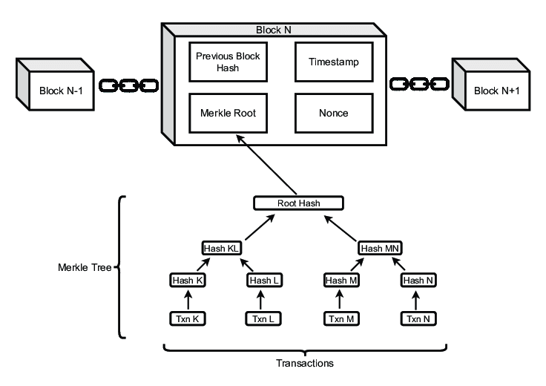

**Fig 3.10: Structure of an Ethereum blockchain node**

**3.2.2 Solidity**

Solidity, Ethereum's programming language, plays a pivotal role in the development of smart contracts. It is intended for the Ethereum Virtual Machine (EVM), enabling developers to write code that automates complex processes, from financial transactions to the execution of business logic. Solidity's syntax is akin to popular languages, making it accessible to a broad developer community.

**3.2.3 Smart Contracts**

Code containing the terms of the smart contract is utilized to get the contract to execute itself. These contracts run on the Ethereum blockchain, ensuring tamper-proof execution. Smart contracts diminish the need for intermediaries by automating processes, offering transparency and trust in a decentralized environment.

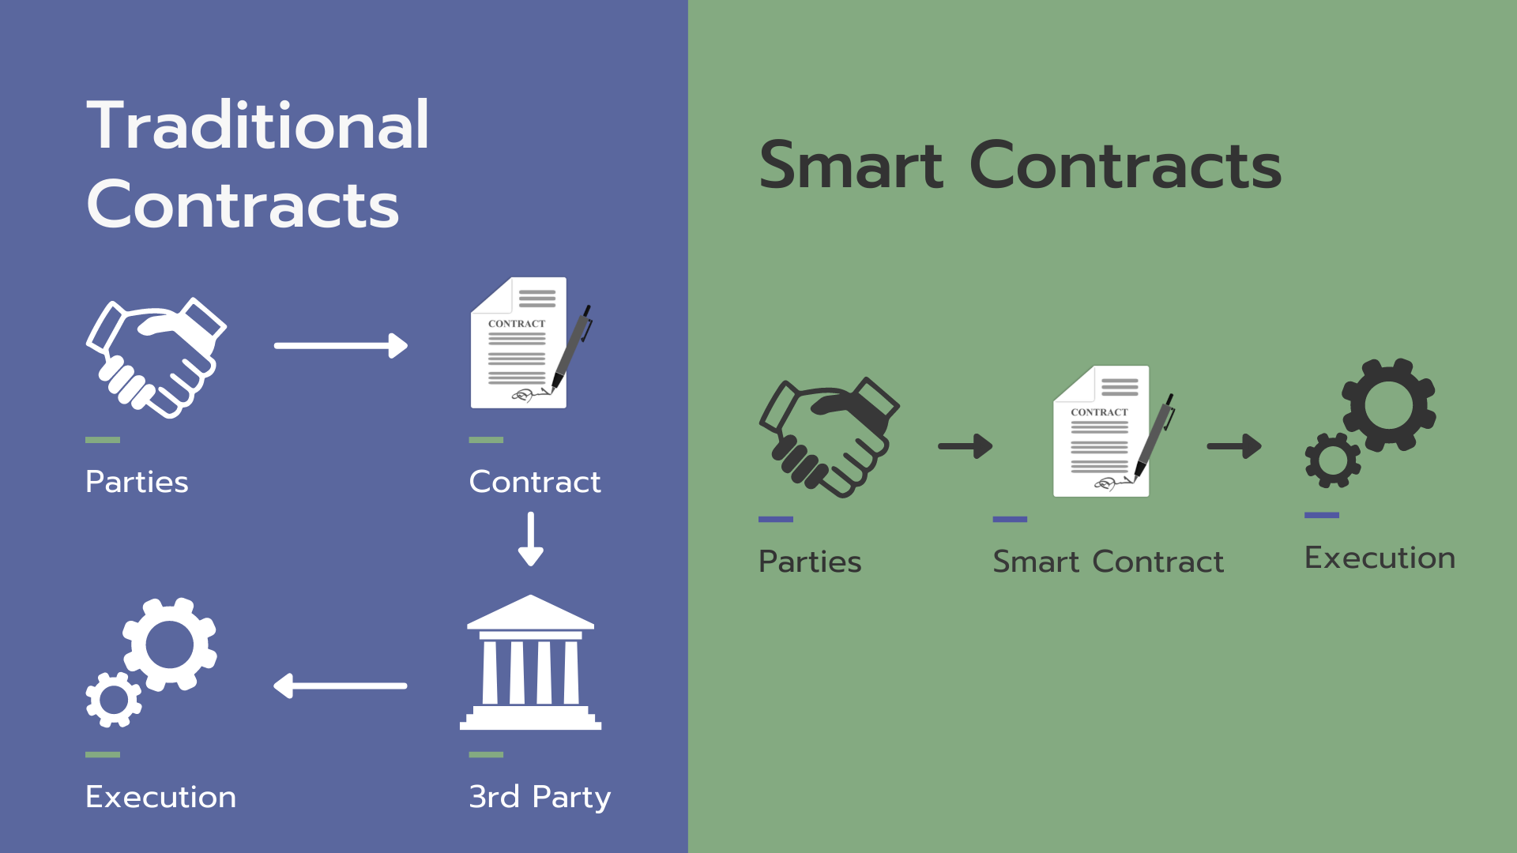

**Fig 3.11: Traditional Contracts vs Smart Contracts**

**3.2.4 Decentralized Applications (dApps)**

Decentralized applications, or dApps, leverage blockchain technology to operate without central authority. In our system development, we focus on the DappOS framework, a platform that streamlines the creation and deployment of Ethereum-based dApps. DappOS provides a foundation for efficient and scalable development, emphasizing user-friendly interfaces and seamless integration with the Ethereum blockchain.

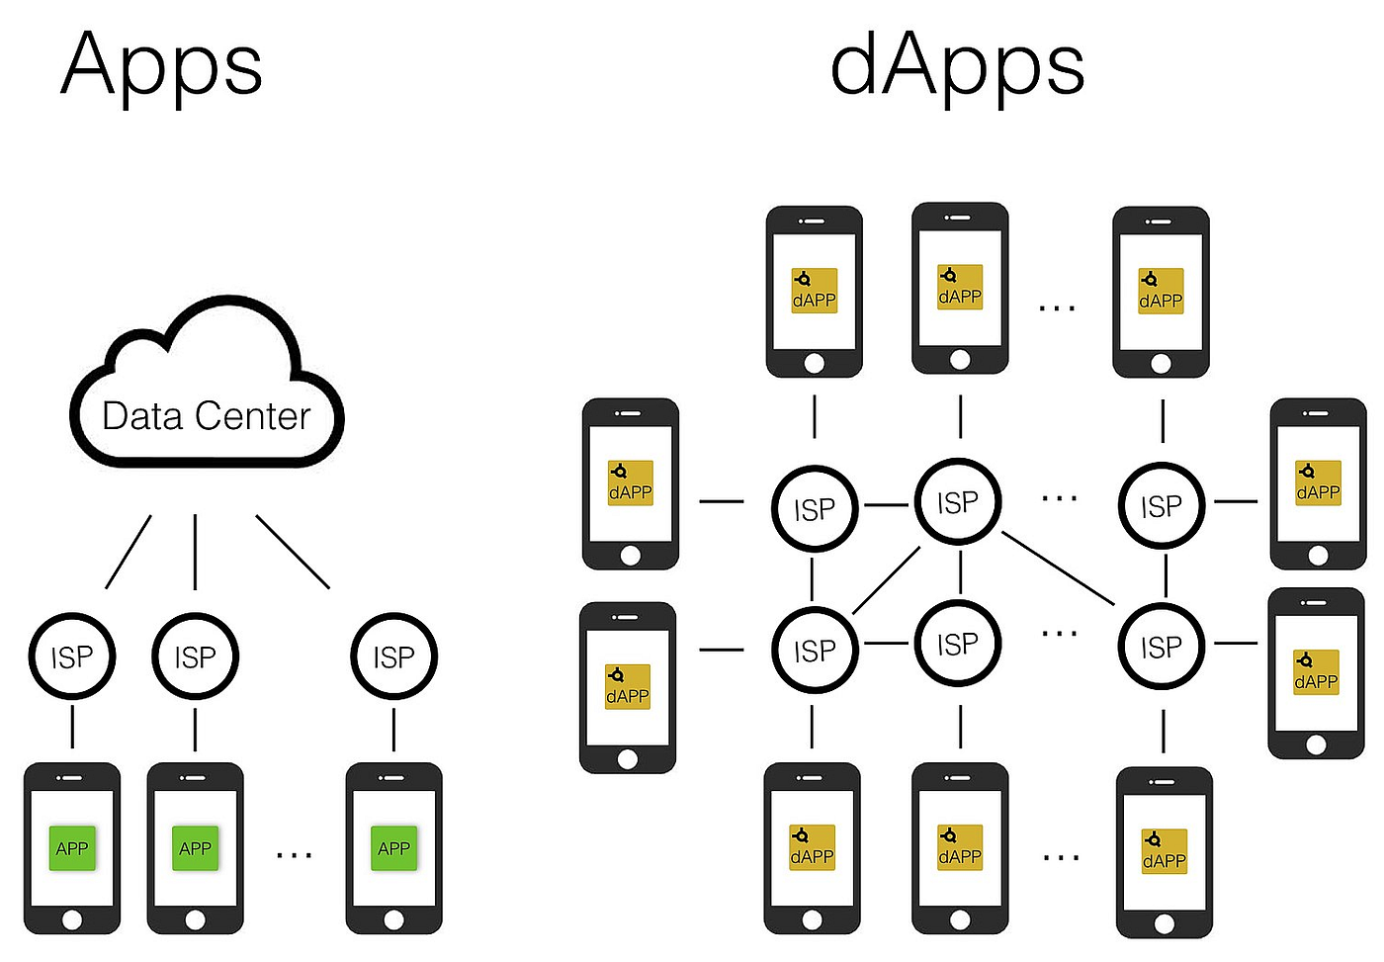

**Fig 12.3: Apps vs dApps**

**3.3 Development Methodology**

The Agile methodology, particularly tailored to suit the characteristics of small teams and rapid application development, is a judicious choice for our project. Several considerations underscore the appropriateness of Agile in this context:

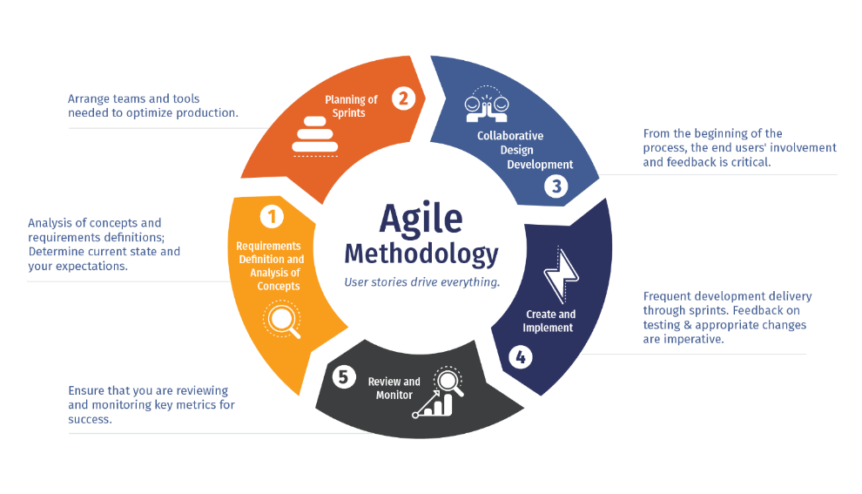

**Fig 3.13: Agile Methodology**

**3.3.1 Suitable for Small Teams**

Agile is inherently scalable, making it well-suited for small, collaborative teams. Unlike traditional methodologies that might become cumbersome in smaller settings, Agile promotes close-knit teamwork and frequent communication. This ensures that every team member is actively involved in decision-making processes, fostering a sense of ownership and accountability.

**3.3.2 Accelerated Application Development**

Our project necessitates a swift development cycle to respond to the dynamic nature of blockchain technology. Agile's emphasis on iterative development, with short, time-boxed iterations known as sprints, aligns seamlessly with our goal of building applications rapidly. By breaking down the project into manageable increments, Agile allows for continuous delivery, enabling us to roll out functional components quickly.

**3.3.3 Testing Integration**

Agile places a strong emphasis on testing throughout the development lifecycle. Each sprint concludes with a review, during which the team evaluates the functionality and performance of the developed features. This iterative testing approach not only ensures the early detection of bugs but also facilitates prompt adjustments, reducing the overall cost of fixing issues.

**3.3.4 Adaptability to Changes**

The blockchain landscape is dynamic, and requirements often evolve as the project progresses. Agile's adaptive nature accommodates changes effectively. Regular meetings and feedback loops provide opportunities to reassess priorities, adjust goals, and incorporate modifications without disrupting the entire development process. This adaptability is crucial for responding to unforeseen challenges and harnessing emerging opportunities.

**3.3.5 Emphasis on Continuous Improvement**

Agile methodologies prioritize continuous improvement through regular retrospectives. Team members reflect on their processes, identifying areas for enhancement in a constructive manner. This commitment to ongoing refinement ensures that the development team consistently optimizes its strategies, making Agile a forward-looking and adaptive framework.

**3.4 Research Design**

**3.4.1 Agile Framework Implementation**

Our research design is centered around the Agile framework, a dynamic and iterative approach to software development. The following outlines how we plan to implement Agile principles within the context of Ethereum blockchain development:

**Iterative Development:** The Agile methodology promotes incremental development, and our project will follow this principle by breaking down the system development process into smaller, manageable increments. These increments, known as sprints, will have defined goals and deliverables, allowing us to build the system in iterative cycles.

**Sprint Planning:** Before each sprint, we will conduct sprint planning sessions to outline the tasks and objectives for the upcoming development cycle. This involves selecting user stories or features to work on, estimating the effort required, and prioritizing tasks based on project goals.

**Continuous Feedback:** Regular feedback loops are a cornerstone of Agile methodology. We will incorporate continuous feedback mechanisms, such as regular sprint reviews and retrospectives. Sprint reviews allow stakeholders to assess the completed work, providing valuable insights for further refinement. Retrospectives, held at the end of each sprint, facilitate a reflective discussion on what worked well and areas for improvement.

**Collaborative Development:** Collaboration is crucial for Agile success. Our development team, though small, will engage in regular communication and collaboration. Daily stand-up meetings will keep everyone informed about progress, challenges, and priorities. Collaboration tools will be employed to ensure effective communication, even in a distributed or remote work environment.

**Adaptability:** The Agile framework is inherently adaptable. As our project unfolds, we anticipate changes in requirements or unforeseen challenges. Agile's flexibility allows us to adapt to these changes efficiently, ensuring that the development process remains responsive to the evolving needs of the Ethereum blockchain application.

**Roles and Responsibilities:** Defined roles and responsibilities contribute to effective Agile implementation. We will clearly delineate roles within the development team, designating a Product Owner to represent stakeholder interests and a Scrum Master to facilitate Agile processes.

**Testing Integration:** Testing will be an integral part of each sprint. Automated testing scripts and manual testing will ensure the reliability and functionality of the developed components. Continuous testing throughout the development process aligns with Agile principles and contributes to the overall quality of the system.

**3.5 Development Process**

**3.5.1 Agile Iterations:**

The system development will be organized into a series of iterative and incremental sprints, following the principles of Agile methodology. The number of sprints and the tasks planned for each sprint are outlined in the table below:

|  |  |  |
| --- | --- | --- |
| **Sprint** | **Tasks** | **Objectives** |
| 1 | * Setup Ethereum Development Environment * Define Smart Contract Structure | Establish the foundational elements for Ethereum development and outline the structure of the smart contract. |
| 2 | * Smart Contract Prototyping * Initial dApp Interface Design | Develop a prototype of the smart contract logic and design the initial user interface for the decentralized application (dApp). |
| 3 | * User Authentication Implementation * Integration of Smart Contracts with dApp | Implement user authentication functionalities and integrate developed smart contracts with the dApp interface. |
| 4 | * Testing of Core Functionalities * User Acceptance Testing (UAT) | Conduct comprehensive testing of core system functionalities and engage in user acceptance testing. |
| 5 | * Optimization and Performance Tuning * Final Testing | Optimize the system for performance and conduct final testing before deployment. |

**3.5.2 Collaboration:**

The collaborative efforts of the development team comprising Shuvo, Setu, Nipun, and Mahsetab are distributed as follows:

* **Shuvo:** Responsible for smart contract development and optimization.
* **Setu:** Focuses on the design and implementation of the dApp interface.
* **Nipun:** Manages user authentication system integration and testing.
* **Mahsetab:** Engages in continuous performance tuning and security auditing.

Collaboration will be facilitated through regular sprint planning meetings, daily stand-ups, and collaborative tools such as version control systems and project management platforms.

**3.5.3 Continuous Integration:**

Continuous integration will be ensured through regular integration and testing cycles within each sprint. Version control systems, automated testing frameworks, and continuous integration tools will be leveraged to maintain the integrity and consistency of smart contracts and dApp components throughout the development process. This ensures that any changes made by individual developers are promptly integrated, tested, and validated as part of the cohesive system.

**3.6 Tools and Technologies**

In the development of the proposed system on the Ethereum blockchain, a carefully selected set of tools and technologies will be employed to ensure efficiency, reliability, and seamless integration. The technological context for the subsequent stages of development is outlined below:

**3.6.1 Solidity - The Smart Contract Programming Language**

Solidity, the primary programming language for smart contracts on the Ethereum blockchain, will be utilized. It is intended for the Ethereum Virtual Machine (EVM), allowing developers to create intricate smart contracts that automate various processes, from financial transactions to complex business logic.

**3.6.2 Remix IDE - Integrated Development Environment**

Remix IDE will serve as the integrated development environment for coding and testing smart contracts. Remix provides a user-friendly interface for writing, deploying, and debugging Solidity smart contracts. Its online nature ensures accessibility and ease of collaboration among the development team members.

**3.6.3 MetaMask - Ethereum Wallet and Gateway to Blockchain**

MetaMask will be employed as the Ethereum wallet and gateway to the blockchain. It facilitates secure management of Ethereum assets and acts as a bridge between traditional browsers and the Ethereum blockchain. This integration ensures a seamless and secure connection for users interacting with the developed decentralized application (dApp).

**3.6.4 DappOS Framework - Simplifying dApp Development**

The development will leverage the DappOS framework, a platform dedicated to streamlining the creation and deployment of Ethereum-based decentralized applications (dApps). DappOS offers a foundation for efficient and scalable development, with a focus on user-friendly interfaces and smooth integration with the Ethereum blockchain.

**3.6.5 Etherscan - Blockchain Explorer and Analytics Platform**

Etherscan will be utilized as a blockchain explorer and analytics platform. It allows for real-time tracking of transactions, contract verification, and overall visibility into the Ethereum blockchain. This tool is invaluable for monitoring the deployment and execution of smart contracts, ensuring transparency and accountability.

**3.6.6 Test Network - Ensuring Secure Development**

A dedicated test network will be implemented to facilitate secure and risk-free development and testing. This environment mimics the Ethereum mainnet but operates with test Ether, preventing any impact on the actual blockchain while providing a realistic setting for testing and refining smart contracts and dApps.

**3.6.7 Web3.js - JavaScript Library for Ethereum Interactions**

Web3.js, a JavaScript library, will be employed to interact with the Ethereum blockchain. It enables seamless integration between the front-end of the dApp and the Ethereum blockchain, allowing for the retrieval and manipulation of data on the blockchain directly from the user interface.

**3.6.8 Ethers - Ethereum JavaScript Library**

Ethers is a powerful JavaScript library for interacting with the Ethereum blockchain. It provides a simple and efficient way to work with smart contracts, handle transactions, and manage Ethereum accounts. The integration of Ethers enhances the development process by offering robust functionalities for Ethereum interactions.

**3.7 Limitations (Methodological Limitation)**

While the Agile methodology offers numerous advantages for software development, its application to Ethereum blockchain development presents specific challenges and limitations:

1. **Blockchain Complexity:** The intricate nature of blockchain technology, particularly Ethereum, introduces complexities that may pose challenges to the iterative and fast-paced nature of Agile. Smart contracts and decentralized applications (dApps) require a deep understanding of blockchain principles, potentially slowing down development cycles.
2. **Smart Contract Security:** Ensuring the security of smart contracts is paramount. The Agile approach's emphasis on rapid development might risk overlooking comprehensive security measures. Striking a balance between speed and security is crucial to prevent vulnerabilities in the final product.
3. **Evolving Standards:** Ethereum, being a rapidly evolving platform, often introduces new standards and updates. Adapting to these changes during short development iterations might pose challenges in maintaining code compatibility and stability.
4. **Limited Precedence:** The Agile methodology in the context of Ethereum blockchain development is relatively novel, with limited precedents. The absence of well-established practices may lead to uncertainties in the development process.
5. **Decentralized Decision-Making:** Decentralized decision-making, a core tenet of blockchain, can sometimes result in delays in achieving consensus, affecting the agility of the development process. Resolving disagreements or reaching consensus on design decisions may take additional time.
6. **User Experience Design:** Designing a user-friendly decentralized application (dApp) can be challenging within the Agile framework, as constant iterations may impact the user experience. Striking a balance between rapid development and a seamless user interface requires careful consideration.
7. **Testing Environment:** Establishing a testing environment that accurately simulates the decentralized and distributed nature of blockchain networks can be complex. Ensuring that tests reflect real-world scenarios is crucial but may require additional effort.
8. **Regulatory Uncertainties:** The evolving regulatory landscape surrounding blockchain and cryptocurrencies introduces uncertainties. Adapting to regulatory changes during short development sprints may require adjustments to ensure compliance.

**3.8 Summary**

In this chapter, we outlined a comprehensive methodology for developing a system on the Ethereum blockchain, employing the Agile methodology. The chosen approach integrates the unique features of Ethereum, including Solidity, smart contracts, and dApps (specifically DappOS). The rationale for selecting the Agile methodology was justified by its adaptability and iterative nature, aligning seamlessly with the dynamic environment of blockchain development. The research design centers on Agile principles, emphasizing collaborative and continuous development. Secondary data collection methods, such as literature reviews and research reports, will guide the development process. The Agile development process was detailed, including iterations, collaboration plans, and strategies for continuous integration. Tools and technologies, limitations, and a budget outline further shape the methodology. This chapter provides a robust framework for the systematic development of the proposed system, ensuring flexibility, adaptability, and efficiency throughout the Ethereum blockchain project.

**Chapter 4**

**Implementation**

**4.1 Overview**

Implementing an Ethereum blockchain involves writing and deploying Solidity smart contracts onto the network, paying gas fees for transaction execution, participating in the Proof of Work consensus mechanism through mining, building decentralized applications on top of the blockchain, interacting with the blockchain through transactions and accounts, utilizing test networks for development, and relying on the Ethereum Virtual Machine to execute smart contract bytecode.

**4.2 Technical Details and Architecture**

Smart contract implementation is enabled via the decentralized, distributed ledger system Ethereum. A peer-to-peer network of nodes is utilized to verify and store transactions in a sequential fashion, thereby constructing a sequence of blocks. The Ethereum Virtual Machine (EVM), the blockchain, and the consensus mechanism are the three primary components that comprise the architecture.

The EVM executes smart contracts as a Turing-complete virtual machine. It ensures that all nodes operate in accordance with the deterministic code in the smart contract. Additionally, memory, storage, and gas calculations are handled for every transaction.

Each block in the blockchain comprises a transaction ledger and a reference to the block that came before it. The blockchain is organized as a linear progression of blocks. Smart contracts or the transmission of Ether (the native cryptocurrency of Ethereum) are both possible with transactions. Mining is the process by which nodes acquire blocks by applying their computational resources in solving a Proof-of-Work puzzle.

**Fig 4.1: Structure of a Block in Blockchain**

The transactional segments of the Ethereum blockchain are structured using a Merkle Tree data structure. A header containing metadata, such as a timestamp, a difficulty value, and a nonce, is present in each block. This metadata also includes a reference to the parent hash of the preceding block. Moreover, blocks contain a record of transactions, encompassing Ether transfers as well as invocations of smart contracts.

At present, Ethereum employs Ethash, a Proof-of-Work (PoW) consensus mechanism. The initial miner to arrive at a legitimate solution to a mathematical conundrum is granted permission to mine the subsequent block. Facilitating the revocation of the blockchain history by adversaries is a critical network security measure that necessitates substantial computational resources.

In order to regulate the distribution of network resources, Ethereum implements the notion of gas. As an indication of computational and storage expenses, every operation within a smart contract utilizes a distinct quantity of gas. Miners are compensated with gas in exchange for incorporating user-executed transactions into a block. Gas guarantees the network’s continued efficiency and prevents resource exploitation.

**Fig 4.2: Ethereum Architecture**

Accounts on Ethereum are classified as contract accounts or Externally Owned Accounts (EOAs). EOAs are entities or individuals that are in possession of the network and are governed by private keys. Smart contracts are linked to contract accounts, which have the capability to execute code in response to triggered transactions.

For the objectives of development and testing, Ethereum offers a range of test networks, including Ropsten, Goerli, Rinkeby, Sapolia, and Kovan. Developers have the ability to deploy their smart contracts and engage with the blockchain through these test networks without the need to utilize actual Ether.

The Ethereum ecosystem provides an extensive selection of frameworks and tools for developing decentralized applications. ETHERS.jS and Web3.jS are widely used JavaScript libraries that facilitate communication with the Ethereum blockchain. Hardhat and Truffle are well-known frameworks for the development, testing, and deployment of smart contracts.

The utilization of Ethereum facilitates the construction of decentralized applications atop the blockchain. By utilizing smart contracts to implement business logic and engage in direct user interactions, these decentralized applications eliminate the necessity for centralized intermediaries.

**4.3 Blockchain Network Setup**

Setting up a blockchain network is a meticulous process involving the establishment of a decentralized system where nodes communicate and validate transactions. In this intricate procedure, defining the network’s architecture, configuring individual nodes, and implementing consensus mechanisms are pivotal steps. These consensus mechanisms, like Proof of Work or Proof of Stake, ensure agreement on the state of the ledger.

The choice of blockchain platform, whether Ethereum, Hyperledger, or others, influences the configuration and deployment specifics. This setup is fundamental to creating a secure and transparent distributed ledger that underpins various applications, from cryptocurrencies to smart contracts and beyond.

**Fig 4.3: Ethereum Decentralized Application Architecture**

Choosing between a public or private network initiates the setup process. In the case of a private network, nodes are deployed using tools like Geth or Besu. The nodes are configured with network IDs and data directories, and a genesis block is established to define initial parameters. Consensus mechanisms, such as Proof of Work or Proof of Stake, determine how nodes agree on the blockchain’s state, with validators selected based on the cryptocurrency they “stake.”

**Fig 4.4: Remix IDE for Ethereum Blockchain development**

Upon node synchronization, smart contracts are deployed, and network interaction is facilitated through tools like Remix or Truffle. Connectivity between nodes is established to ensure seamless communication. Key pair management and secure access are imperative for maintaining the Ethereum blockchain network’s integrity and confidentiality.

**Fig 4.5: MetaMask Wallet**

**Fig 4.6: MetaMask Ethereum Transaction**

The deployment of smart contracts governs the logic and behavior of decentralized applications (DApps), concluding the setup process. The efficiency, security, and functionality of the Ethereum blockchain network are ensured through a meticulously planned configuration.

**4.4 Smart Contract Development and Deployment**

Developing and deploying smart contracts constitute crucial stages in the creation of decentralized applications (DApps) on blockchain platforms like Ethereum. In the development phase, developers utilize languages such as Solidity to create self-executing contracts that autonomously enforce predefined rules when specific conditions are met. Following the coding and testing of the smart contract, a comprehensive review is undertaken to detect and address potential vulnerabilities.

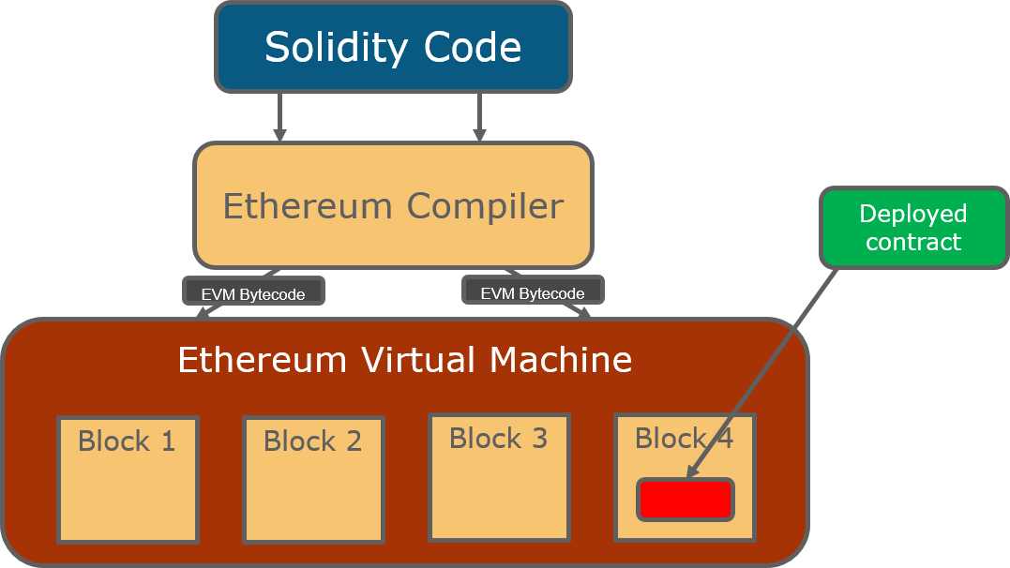

**Fig 4.7: Smart Contract Development**

Subsequent to this, the smart contract undergoes compilation into bytecode, facilitating its deployment on the blockchain. The deployment process entails sending the contract to the network, where it assumes an immutable and transparent role within the blockchain. Users can then engage with the deployed smart contract, activating its predetermined functions and ensuring the execution of decentralized processes.

**Fig 4.8: Solidity code for Shipping Container Management**

**Fig 4.9: Solidity code for Shipping Container Management**

**Fig 4.10: Smart Contract Compilation and Deployment**

**Fig 4.11: Smart Contract Functionality**

**Fig 4.12: Data insertion and Transaction created**

**Fig 4.13: Fetching the data and details of transaction fee**

Upholding security standards, including rigorous testing and code audits, plays a pivotal role in mitigating risks linked to vulnerabilities, ultimately bolstering the reliability and trustworthiness of the deployed smart contract.

**4.5 Decentralized Application (dApp) Development**

Developing Decentralized Applications (dApps) entails crafting applications designed to function on blockchain networks, delivering an experience characterized by decentralization and transparency for users. Skilled developers employ blockchain-specific languages like Solidity (in the context of Ethereum) to script the smart contracts that govern the application’s logic. These intelligent contracts find their place on the blockchain, guaranteeing the tamper-resistant execution of predefined functions.

The essence of dApps lies in their decentralized nature, operating seamlessly on a peer-to-peer network and gracefully sidestepping the necessity for a central authority. Within this decentralized landscape, user data and transactions find secure refuge on the blockchain, fostering transparency and immutability. Interactions within dApps unfold seamlessly, often involving cryptocurrency transactions executed without the need for intermediaries.

**Fig 4.14: Deploying the dApp in test network and using faucet for mining Ethereum**

**Fig 4.15: Verification of Smart Contract Deployment in Blockchain**

**Fig 4.16: Decentralized Application Interface**

**Fig 4.17: Decentralized Application Interface**

In the developmental saga of dApps, crucial considerations revolve around security, scalability, and user experience. These factors serve as guiding principles, ensuring the dependability and user-friendly nature of the emerging decentralized applications. As developers navigate this landscape, they strive to harmonize innovation with reliability, weaving a narrative where the essence of decentralized technology meets the demands of a new era.

**4.6 Data Storage and Encryption**

Blockchain technology has revolutionized our approach to data storage and security by introducing decentralized and tamper-resistant mechanisms that redefine information management.

**Decentralized Data Storage:** In contrast to traditional centralized servers vulnerable to single points of failure, blockchain embraces a decentralized architecture where data is dispersed across a network of nodes. Each participant holds a copy of the complete blockchain, ensuring redundancy and resilience. This decentralized structure enhances data availability and minimizes the risk of data loss due to system failures or cyber-attacks.

**Immutability and Data Integrity:** At the heart of blockchain lies the principle of immutability. Once data is recorded in a block and incorporated into the chain, altering it becomes nearly impossible. Cryptographic hash functions link each block to the preceding one, requiring tampering attempts to change all subsequent blocks—an increasingly impractical task as the blockchain expands. Immutability preserves the integrity of historical data, establishing a reliable and transparent record.

**Encryption in Blockchain:** Encryption plays a vital role in securing sensitive information within the blockchain. Smart contracts, which often handle encrypted data, automate and enforce predefined rules on the blockchain. Public and private key cryptography is commonly utilized to secure transactions and communications. Public keys, visible to all participants, facilitate encryption, while private keys, known only to the data owner, enable decryption. This asymmetric encryption ensures data confidentiality and privacy.

**Fig 4.18: Data Security of Blockchain**

**Privacy Concerns and Solutions:** Despite blockchain’s inherent security features, privacy concerns persist, particularly in public blockchains where data is visible to all participants. This poses challenges for confidential information. Privacy-centric solutions, such as zero-knowledge proofs and ring signatures, enable information verification without revealing the actual data. These cryptographic techniques enhance privacy, expanding the applicability of blockchain to various use cases, including those requiring stringent confidentiality.

**4.7 Results and Findings**

The use of the Ethereum blockchain in tracking and preventing illicit products in shipping containers has the potential to greatly improve supply chain security, traceability, and compliance, thereby lowering the risks associated with illegal activities in the shipping industry.

**Immutable Records:** Ethereum's blockchain provides an immutable and transparent ledger, ensuring that data cannot be changed or tampered with once it is recorded. This feature improves the security and dependability of the recorded information by making it harder for unauthorized parties to alter data, lowering the danger of criminal actions like smuggling or counterfeiting.

**Smart Contracts:** The smart contract capability of Ethereum can be used to automate and enforce the conditions of agreements between different parties involved in the shipping and tracking of products. Smart contracts can specify ownership transfer requirements, initiating automatic actions (such as payment release) after predefined criteria are met. This can aid in the prevention of illegal operations by ensuring that only approved and confirmed transactions take place throughout the supply chain.

**Enhanced Transparency:** Transparency is improved since Ethereum's blockchain allows for real-time and transparent tracking of shipping container movements and associated cargo. This visibility can aid in detecting inconsistencies or irregularities in the supply chain, allowing for prompt intervention to avoid the movement of illegal or unapproved commodities.

**Reduced Fraud and Counterfeiting:** The blockchain technology used by Ethereum makes it more difficult for illegal or counterfeit goods to enter the supply chain. There is a decreased likelihood of counterfeit goods being distributed or smuggled in shipping containers because to the permanent and traceable nature of blockchain records, which enable the verification of product provenance.

**Supply Chain Traceability:** Ethereum's blockchain enables the recording of a product's provenance and travel, providing a detailed and auditable trace of its movement through the supply chain. This traceability can aid in identifying and intercepting illegal commodities at various stages of transportation, lowering the possibility that such illegal activities will reach their intended destinations.

**Stakeholder Collaboration:** The decentralized and interoperable structure of the Ethereum blockchain enables many stakeholders, including as shipping firms, customs officials, suppliers, and retailers, to safely access and contribute to the shared data. This collaborative and transparent approach can help to create a uniform and trustworthy system for preventing the transportation of illegal products in shipping containers.

**Streamlined Compliance and Documentation:** Ethereum blockchain's smart contract capabilities can automate compliance checks and documentation validation, reducing the administrative burden and potential errors associated with manual processes. This streamlining of compliance procedures helps ensure that only legitimate goods are transported, contributing to a more compliant and secure supply chain.

**Compliance and risk mitigation:** Using the Ethereum blockchain to track and prevent illicit objects conforms with regulatory requirements and industry norms, resulting in a more compliant and safe supply chain. Companies can limit the legal, financial, and reputational risks connected with handling contraband or illicit commodities by minimizing the danger of criminal activity in shipping containers.

**4.8 Summary**

The implementation of the Ethereum blockchain signifies a transformative paradigm in decentralized and programmable platforms. Distinct from Bitcoin, Ethereum’s scope extends beyond simple transactions to embrace a diverse array of decentralized functionalities. At its core are smart contracts—self-executing agreements encoded in code—empowering developers to create decentralized applications (DApps) across sectors like finance and gaming. Ethereum’s dominance in decentralized finance (DeFi), support for Decentralized Autonomous Organizations (DAOs), and facilitation of non-fungible tokens (NFTs) underscore its versatility. The transition to Ethereum 2.0, incorporating Proof of Stake (PoS) and shard chains, aims to enhance scalability and sustainability, reinforcing Ethereum’s commitment to an efficient and interconnected blockchain ecosystem. The Ethereum Improvement Proposal process, driven by a dynamic community, reflects ongoing innovation and collaboration, establishing Ethereum as a preferred space for blockchain development.

**Chapter 5**

**Conclusion**

**5.1 Overview**

This section provides a brief glance at the entire thesis, encapsulating our main goals, the methodologies employed, and the outcomes achieved. It touches on the essence of our proposed blockchain solution for supply chain management, emphasizing its role in tracking and preventing illegal goods in shipping containers. We'll explore the significance of our contributions to the field of supply chain management, summarize key findings from our research, acknowledge any limitations encountered, and outline the pathway for future work. Additionally, ethical considerations and integration possibilities with industry practices will be discussed. Finally, this chapter concludes with a summary and recommendations for future research, encapsulating the comprehensive journey of our study.

**5.2 Summary of the Proposed Blockchain-Based Solution**

In summary, our proposed blockchain-based solution for supply chain management is a robust framework designed to address the challenges of tracking and preventing illegal goods in shipping containers. At its core, the solution leverages blockchain technology to establish a transparent, secure, and decentralized system. The key components include smart contracts, which autonomously execute predefined rules, and decentralized applications (dApps), offering a user-friendly interface for stakeholders.

The blockchain ledger ensures an immutable record of transactions, providing an unalterable history of goods throughout the supply chain. This not only enhances traceability but also establishes a trustless environment, minimizing the risk of fraudulent activities.

The integration of the proposed solution involves creating a comprehensive ecosystem where all relevant parties, including manufacturers, shippers, and customs, can seamlessly interact and validate the authenticity of goods. The use of cryptographic techniques ensures data integrity and privacy, while the decentralized nature of the system reduces the dependency on central authorities.

By summarizing the essential features and functionalities, this solution aims to revolutionize supply chain management by introducing transparency, security, and efficiency into the process of tracking and preventing the circulation of illegal goods within shipping containers.

**5.3 Contribution to Supply Chain Management**

Our blockchain-based solution brings transformative contributions to supply chain management, particularly in combating the challenges associated with illegal goods in shipping containers. The key contributions include:

1. **Enhanced Transparency:** The blockchain ledger ensures transparency at every stage of the supply chain, providing real-time visibility into the movement and status of goods within shipping containers.
2. **Immutable Record Keeping:** Smart contracts enable temper-proof record-keeping, preventing unauthorized alterations to crucial data. This immutability ensures the integrity of information related to goods and shipments.
3. **Traceability and Accountability:** The solution enables end-to-end traceability, holding all participants accountable for their actions. Every transaction, from production to delivery, is recorded and accessible, facilitating quick identification of the origin and movement of goods.
4. **Efficient Verification:** Using cryptographic techniques, the solution ensures secure and efficient verification of data, reducing the risk of counterfeit products entering the supply chain.
5. **Real-time Alerts and Notifications:** Smart contracts trigger real-time alerts and notifications in response to suspicious activities or deviations from the expected route, allowing stakeholders to take immediate preventive actions.
6. **Collaborative Security Measures:** The decentralized nature of blockchain promotes collaboration among stakeholders. By securely sharing information, participants collectively contribute to the security of the supply chain, reducing vulnerabilities to illegal activities.

**5.4 Key Findings**

The implementation and analysis of our blockchain solution for supply chain management have yielded significant findings:

1. **Increased Accountability:** The introduction of blockchain technology enhances accountability across the supply chain. Participants are more accountable for their roles, leading to improved reliability in the tracking of goods.
2. **Reduced Instances of Illegal Goods:** The solution effectively reduces the occurrences of illegal goods in shipping containers. The transparent and traceable nature of the blockchain discourages illicit activities and provides a deterrent against unauthorized alterations.
3. **Enhanced Efficiency in Verification:** The use of cryptographic verification processes significantly improves the efficiency of product verification. This reduces the time and resources required to validate the authenticity of goods, streamlining the supply chain.
4. **Quick Response to Anomalies:** Real-time alerts generated by smart contracts enable swift responses to anomalies or deviations from expected routes. This proactive approach minimizes the impact of irregularities and contributes to the prevention of illegal activities.
5. **Improved Collaboration and Communication:** The decentralized and collaborative features of the blockchain foster improved communication among supply chain participants. This leads to better coordination, reducing delays and enhancing overall efficiency.
6. **Validation of Blockchain in Supply Chain Security:** The successful implementation validates the potential of blockchain in fortifying supply chain security. It establishes a robust framework for addressing the vulnerabilities associated with illegal goods and illicit activities.

**5.5 Significance of the Study**

This study holds paramount significance in the realm of supply chain management by introducing a groundbreaking blockchain-based solution aimed at countering illicit activities in shipping containers. The study's broader impact is articulated through several key dimensions:

Firstly, the implementation of this blockchain solution significantly elevates security and transparency in the supply chain. Leveraging decentralized and tamper-resistant ledgers addresses critical vulnerabilities, fostering a more secure environment for the transportation of goods.

Secondly, the study's dedicated focus on preventing illegal goods in shipping containers serves as a crucial step toward mitigating criminal activities within the supply chain. The transparency and traceability inherent in blockchain act as deterrents, reducing the likelihood of illicit practices.

Moreover, the introduction of blockchain to supply chain management represents a technological innovation that can potentially revolutionize conventional practices. The study's application of blockchain demonstrates its capacity to bring about positive disruptions, enhancing efficiency and resilience in supply chain operations.

The blockchain solution contributes to improved operational efficiency by streamlining verification processes and enabling real-time tracking. This not only reduces instances of illegal goods but also enhances coordination among stakeholders, leading to cost savings throughout the supply chain.

On a global scale, the study's findings have the potential to impact trade security, particularly as supply chains become increasingly interconnected. The adoption of blockchain technology in supply chain management could set new standards for secure and transparent cross-border transactions.

Lastly, this study serves as a model for future research endeavors seeking to leverage emerging technologies for supply chain security. The methodologies and insights gained can guide the development and implementation of similar solutions, addressing evolving challenges in the field.

**5.6 Limitations**

While this study endeavors to present a robust blockchain-based solution for supply chain management, it is imperative to acknowledge certain limitations that may impact the interpretation and application of the findings:

1. **Blockchain Complexity:** The intricacies of blockchain technology, particularly in the context of supply chain management, introduce a learning curve. The complexity of implementing and integrating blockchain solutions might pose challenges for organizations with limited technological expertise.
2. **Resource Constraints:** The successful deployment of the proposed solution relies on adequate resources, both in terms of technology infrastructure and skilled personnel. Small and medium-sized enterprises (SMEs) with limited resources may find it challenging to adopt and maintain the blockchain system effectively.
3. **Industry Adoption:** The broader acceptance of blockchain within the supply chain industry is still evolving. Resistance to change and the need for industry-wide collaboration may impede the rapid adoption of blockchain solutions, hindering the system's overall effectiveness.
4. **Regulatory Landscape:** The study operates within the existing regulatory framework, but the dynamic nature of blockchain regulation introduces uncertainties. Navigating legal requirements and ensuring compliance may present challenges, particularly as regulations evolve.
5. **Data Standardization:** Variability in data formats and standards across the supply chain ecosystem poses a potential limitation. Achieving universal data standardization is an ongoing challenge that could impact the seamless integration of the blockchain solution.
6. **Scalability Concerns:** The scalability of blockchain networks, particularly in handling a large volume of transactions, is a common concern. While the study addresses scalability to a certain extent, scalability challenges may emerge as the system scales up to accommodate extensive supply chain networks.
7. **User Adoption:** Successful implementation relies on user acceptance and adoption. Resistance to change, lack of training, or unfamiliarity with blockchain technology among stakeholders could impede the smooth integration of the proposed solution.
8. **Evolution of Technology:** The rapid evolution of technology introduces an inherent limitation. While the study's solution aligns with current technological standards, ongoing advancements may necessitate updates or modifications to maintain relevance.

**5.7 Future Work**

As we conclude the current study, it is imperative to outline potential avenues for future research and development in the dynamic realm of blockchain-based supply chain management. The insights gained from this study serve as a springboard for future endeavors aimed at enhancing and expanding the scope of blockchain applications in the supply chain.

1. **Enhanced Interoperability:** Future research could delve into enhancing the interoperability of blockchain solutions across diverse supply chain ecosystems. Establishing standardized protocols for data exchange and smart contract execution would contribute to a more seamlessly connected and efficient supply network.
2. **Integration with Emerging Technologies:** The integration of blockchain with emerging technologies such as the Internet of Things (IoT) and Artificial Intelligence (AI) holds immense potential. Exploring how these technologies can synergize to bolster supply chain transparency, traceability, and efficiency is an avenue worth investigating.
3. **Regulatory Frameworks and Compliance:** The evolving landscape of regulatory frameworks surrounding blockchain and supply chain management warrants continuous exploration. Future research could focus on developing frameworks that ensure both legal compliance and the preservation of the decentralized nature of blockchain networks.
4. **Scalability Solutions:** Given the scalability challenges inherent in blockchain networks, future work could concentrate on devising and testing scalable solutions. This involves addressing issues related to transaction speed, data storage, and network throughput to accommodate the scale and complexity of global supply chains.
5. **User Education and Adoption:** A crucial aspect for successful implementation is user education and adoption. Future research can explore strategies to facilitate a smoother transition for stakeholders, including training programs, user-friendly interfaces, and awareness campaigns.
6. **Blockchain in Circular Supply Chains:** Investigating the application of blockchain in circular supply chains, where resources are reused and recycled, presents an exciting avenue. This could contribute to sustainable and environmentally friendly supply chain practices.
7. **Real-world Implementation Studies:** Future research could focus on extensive real-world implementation studies, collaborating with industry partners to deploy and assess blockchain solutions in diverse supply chain scenarios. This would provide valuable insights into the practical challenges and benefits.
8. **Security and Privacy Enhancements:** Continuous research is needed to enhance the security and privacy features of blockchain in supply chain applications. This includes exploring advanced cryptographic techniques and privacy-preserving mechanisms to safeguard sensitive information.

**5.8 Integration with Industry Practices**

The integration of blockchain-based solutions into existing industry practices is a pivotal consideration for the practical application of our proposed solution in supply chain management. While the potential benefits are substantial, it is essential to acknowledge both the challenges and opportunities associated with this integration.

**Challenges:**

1. **Technological Adoption Barriers:** One significant challenge lies in overcoming potential resistance to technological change within established industry practices. Integrating blockchain requires adapting to new tools and processes, which may face reluctance from stakeholders accustomed to traditional methods.
2. **Standardization Issues:** Achieving standardization across diverse industry practices poses a challenge. Different supply chain entities may use varied systems and protocols, necessitating collaborative efforts to establish standardized practices for blockchain adoption.
3. **Data Interoperability:** Ensuring seamless data interoperability among different participants in the supply chain is critical. Variations in data formats, structures, and systems must be addressed to enable effective communication and collaboration through the blockchain.

**Opportunities:**

1. **Enhanced Transparency and Trust:** The integration of our blockchain solution offers the opportunity to significantly enhance transparency and trust within industry practices. By providing an immutable and shared ledger, stakeholders can access real-time, trustworthy information about the entire supply chain process.
2. **Streamlined Processes:** Blockchain's decentralized nature allows for the streamlining of processes by eliminating intermediaries, reducing paperwork, and enhancing the overall efficiency of supply chain operations. This can result in cost savings and improved timelines.
3. **Collaborative Ecosystems:** Integrating blockchain encourages the formation of collaborative ecosystems within industry. Smart contracts enable automated, trustless agreements, fostering stronger partnerships and cooperation among various entities in the supply chain.

**Potential Collaborations:**

1. **Industry Associations:** Collaborating with industry associations can facilitate the development of standardized practices for blockchain integration. These associations can act as catalysts for knowledge exchange and consensus-building among stakeholders.
2. **Technology Providers:** Partnering with established technology providers specializing in blockchain solutions can expedite the integration process. These providers bring expertise in developing and implementing blockchain systems tailored to industry requirements.
3. **Government Initiatives:** Engaging with government initiatives promoting the adoption of emerging technologies in supply chain management can open avenues for collaboration. Aligning with regulatory frameworks and initiatives can help overcome legal and compliance challenges.

**5.9 Conclusion**

In conclusion, the implementation of a blockchain-based solution for supply chain management represents a significant stride towards addressing the challenges of tracking and preventing illegal goods in shipping containers. This study has elucidated the core components and functionalities of the proposed solution, showcasing its potential in enhancing transparency, security, and accountability within the supply chain. The ethical considerations highlighted underscore the importance of responsible implementation, ensuring data privacy, fairness, and inclusivity. As we navigate the evolving landscape of supply chain technology, this blockchain-based solution stands as a testament to the transformative power of innovative technologies in mitigating illicit activities and fostering a more resilient and trustworthy supply chain ecosystem.

**5.10 Summary**

In summary, this thesis has delved into the development and implications of a blockchain-based solution for supply chain management, specifically targeting the tracking and prevention of illegal goods in shipping containers. The proposed solution, with its emphasis on transparency, automation through smart contracts, and decentralized data storage, contributes significantly to advancing supply chain management practices. The research findings highlight the potential impact of blockchain technology in creating more secure and efficient supply chains. As we look ahead, the integration of blockchain into industry practices and the continuous exploration of ethical considerations pave the way for a future where technology aligns with ethical standards, ensuring a sustainable and trustworthy supply chain landscape.

**References:**

[1] Supply Chain Security: A Guide for Businesses, US Department of Homeland Security, 2023.

[2] Toyota Recall to Cost $1.1 Billion, The Wall Street Journal, 2011.

[3] FDA Warns Consumers About Counterfeit Version of Blood Thinner Xarelto, US Food and Drug Administration, 2018.

[4] US Accuses China of Hacking American Solar Companies, The New York Times, 2015.

[5] Supply Chain Security: A Framework for Action, World Economic Forum, 2011.

[6] NotPetya Ransomware Attack Causes Billions in Damage, Wired, 2017.

[7] $10 Million Worth of Computer Chips Stolen in China, Bloomberg, 2018.

[8] Group Arrested for Counterfeiting and Selling $100 Million Worth of Automotive Parts, US Department of Justice, 2019.

[9] Emerging Technologies for Tracking Shipping Containers, World Economic Forum, 2023.

[10] Blockchain for Supply Chain Management: A Comprehensive Guide, Deloitte, 2023.

[11] The Future of Supply Chain Management: How Emerging Technologies Are Transforming the Industry, McKinsey & Company, 2023.

[12] Blockchain for Supply Chain Management: Use Cases and Benefits, IBM, 2023.

[13] V. Buterin, "Ethereum: A next-generation smart contract and decentralized application platform," [Online]. Available: https://github.com/ethereum/wiki/wiki/White-Paper.

[14] G. Wood, "Ethereum: A secure decentralised generalised transaction ledger. Ethereum project yellow paper, 151, 1-32" [14].

[15] J. H. Xiao and X. Liu, "Development of multimodal transport in China," in Contemporary Logistics in China, pp. 137-160, Springer.

[16] D. Song, "A literature review, container shipping supply chain: Planning problems and research opportunities," Logistics, vol. 5, no. 2, p. 41, 2021.

[17] M. Jović, M. Filipović, E. Tijan, and M. Jardas, "A review of blockchain technology implementation in the shipping industry," Pomorstvo, vol. 33, no. 2, pp. 140-148, 2019.

[18] Smart Contracts: What They Are and How They Work, IBM, 2023.

[19] M. Kouhizadeh, S. Saberi, J. Sarkis, and L. Shen. (2019). “Blockchain technologyand its relationships to sustainable supply chain management,” Interna-tional Journal of Production Research

[20] C. S. Yang. (2019). “Maritime shipping digitalization: Blockchain-based technology applications, future improvements, and intention to use,” Transportation Research Part E: Logistics and Transportation Review, vol. 131, pp.108–117

[21] Tsiulin, S., Reinau, K. H., Hilmola, O.-P., Goryaev, N., and Karam, A . (2020). “Blockchain-based applications in shipping and port management: a literature review towards defining key conceptual frameworks,” Review of International Business and Strategy

[22] M. Jardas, M. Jovi¯c, M. Filipovi¯c, and E. Tijan. (2019). “A review of blockchain technology implementation in shipping industry,” Pomorstvo, vol. 33,no. 2, pp. 140–148

[23] Jovanovic M, KostiŇc N, Sebastian I. M., and Sedej T. (2019). “Managing ablockchain-based platform ecosystem for industry-wide adoption: Thecase of tradelens,” Technological Forecasting and Social Change, vol. 184,p. 121981

[24] R. Kamath. (2018) . “Food traceability on blockchain: Walmart’s pork and mangopilots with ibm,” The Journal of the British Blockchain Association, vol. 1,no. 1, p. 3712

[25] S. Matalonga, K. Dahal, and R. C. Koirala. (2019). “Supply chain using smartcontract: a blockchain enabled model with traceability and ownershipmanagement,” in 2019 9th International Conference on Cloud Computing, Data Science & Engineering (Conﬂuence).

[26] K. Lakshm and P. Sangeerth. (2021). “Blockchain based smart contracts inautomation of shipping ports,” in 2021 6th International Conference onInventive Computation Technologies (ICICT).

E. Hirata, D. Watanabe, and M. Lambrou, “Shipping digitalization and

automation for the smart port,” 2022

[27] E. Hirata, D. Watanabe, and M. Lambrou. (2022). “Shipping digitalization and automation for the smart port,”

[28] H. Hasan, E. AlHadhrami, A. AlDhaheri, K. Salah, and R. Jayaraman. (2019).“Smart contract-based approach for efﬁcient shipment management,”Computers & Industrial Engineering, vol. 136, pp. 149–159